­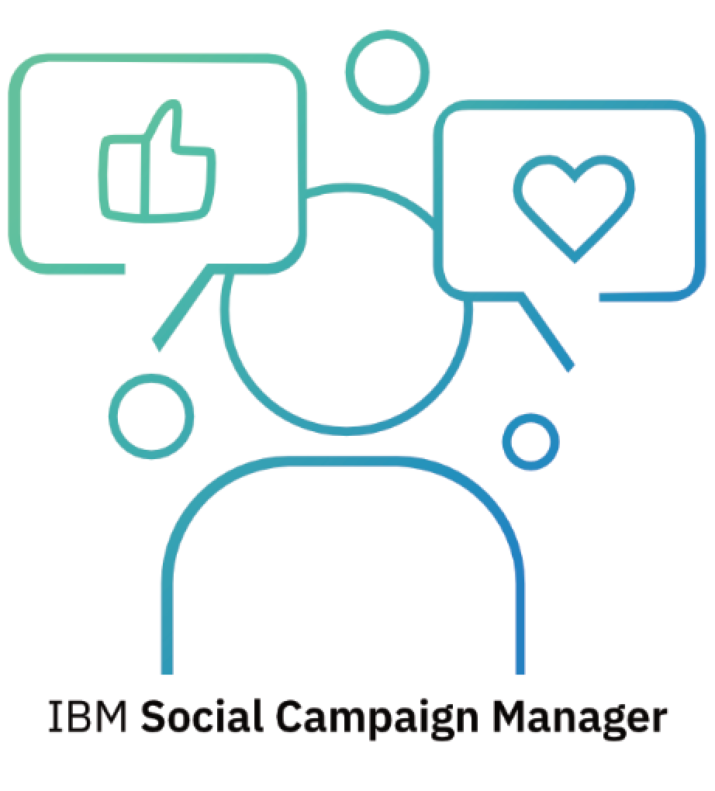

IBM Ireland **Cloud & AI Foundry**

**Contact**: Gavin Shorten

[shorteng@ie.ibm.com](mailto:shorteng@ie.ibm.com)

**Table of Contents**

1 Introduction 4

2 Social Media and Direct Messaging Data Sources 4

3 Systems architecture 5

3.1 High level diagram 5

3.2 Adapters 6

3.3 Watson 6

3.4 Alternative conversation assistant services 7

3.5 Watson Assistant Concepts 7

3.6 Conversation Action Hander 9

3.7 Direct Message Processing Flow 10

3.8 Workspace Picker 15

3.9 Campaign Dialog Tree 16

3.10 Data Persistence 22

3.11 APIs 24

4 Demo 29

4.1 Social Campaign Manager 29

4.1.1 Creating a campaign 29

4.1.2 Engaging with the public 32

4.1.3 Viewing the results 33

4.1.4 Refining the campaign questions and answers 39

4.1.5 Editing a campaign 39

4.1.6 Deleting a campaign 39

5 Conclusion 40

**Table of Figures**

Figure 1.1 The Social Campaign Manager Overview 4

Figure 2.1 The Social Campaign Manager uses Twitter to consult public opinion 5

Figure 3.1 Social Campaign Manager – High-level architecture diagram 6

Figure 3.2 Conversation context is kept in an in-memory database 9

Figure 3.3 The Action Handler is where the conversation is processed 10

Figure 3.4 Twitter Data Provider automatically replies to tweets related to a social media campaign 11

Figure 3.5 Use case diagram of optional in-chat capabilities of the SCM showing which actor is responsible for which capability 12

Figure 3.6 What happens when the system receives a Direct Message (DM) from Twitter 13

Figure 3.7 Workspace Picker is a special type of Watson Assistant Dialog 15

Figure 3.8 Use case diagram of the Workspace Picker decision making 16

Figure 3.9 A simplified representation of the campaign dialog tree 17

Figure 3.10 Watson Assistant Welcome Message 17

Figure 3.11 Twitter direct message with name variable populated 18

Figure 3.12 More detailed Campaign Dialog Nodes Structure 19

Figure 3.13 Multiple-choice question option in SCM 20

Figure 3.14 A list of multiple-choice answers as entities in Watson Assistant 21

Figure 3.15 Multiple-choice answers are entity values with synonyms 21

Figure 3.16 Database Entity Relationship Diagram 22

Figure 4.1 Create a draft campaign 29

Figure 4.2 Campaign creation – Campaign questions 29

Figure 4.3 Campaign creation – Adding questions and answers 30

Figure 4.4 Campaign creation – Providing answers to default questions around consent 31

Figure 4.5 Campaign creation - step 4 – Creating campaign questions 31

Figure 4.6 Post Tweet and/or Publish Campaign 31

Figure 4.7 A user being asked to speak in direct messages after reply to the bot 32

Figure 4.8 A direct message conversation with the chatbot 33

Figure 4.9 Social Campaign Manager dashboard viewing list of campaigns 34

Figure 4.10 Social Campaign Manager dashboard viewing summary and metrics 34

Figure 4.11 Social Campaign Manager dashboard viewing demographics 35

Figure 4.12 Social Campaign Manager dashboard viewing question answers 35

Figure 4.13 Social Campaign Manager dashboard viewing answers to multiple choice questions 36

Figure 4.14 Responses to a free form question 36

Figure 4.15 Social Campaign Manager dashboard viewing analysis of answers to why questions 37

Figure 4.16 Viewing the word cloud of all free form answers including answers not fitting the question 38

Figure 4.17 Viewing user questions chatbot was unable to answer 38

Figure 4.18 Social Campaign Manager - Deleting a campaign and all its data 39

# Introduction

The Social Campaign Manager’s (SCM) main goal is to “capture the voice of the public”. The application is suitable in any use case where stakeholders wish to gather input from members of the public or a target cohort of people. Typically, this is done through polls, surveys and public consultations, which take a lot of time, money and effort to establish and run. They also have a potential risk of being biased if all sides are not adequately represented. This has brought about a drive to find a more open and inclusive way of capturing the voice of the public, but this typically comes at a high cost of having a lot of staff spending time talking face-to-face with members of the public, and manually recording and analysing the results. Social media and analytics offer a solution to this, if implemented correctly, by allowing anyone with a free social media account to voice their opinions and having a system in place to aggregate them and highlight key points of interest.

The SCM looks to try to improve on this by using cognitive solutions to drive conversation and provoke reactions in a free form manner not restricted by multiple choice answers, allowing members of the public to truly express their opinions. Using a combination of Natural Language Understanding techniques, these responses will be analysed and displayed on a dashboard creating an actionable set of insights.

Although this prototype application was built in collaboration with health care policy makers it could be used by any stakeholder who wants to capture information using Q&A style engagements over social media or via a direct messaging service with their following.



Figure 1.1 The Social Campaign Manager Overview

# Social Media and Direct Messaging Data Sources

The Social Campaign Manager (SCM) allows any stakeholder to create a campaign that will be run via social media. Twitter was chosen as the initial social media platform to act as the user interface as it has a very large user base and it gives the public a way to voice their opinions. This is a good fit for the SCM. It gives the policy maker access to their target audience and the public have a modern, familiar way to respond with their opinion. When a campaign is launched through the social dashboard, the chatbot uses a Twitter account to send out a descriptive, initial Tweet about the topic. The public are invited to respond with their opinion through private direct messages to the Twitter account. As the chatbot is a software service it needs a programmatic way to handle this interactivity. Twitter provides a development toolkit to do this. Tweets, Tweet responses and private direct messages can be automated using Twitter’s API.

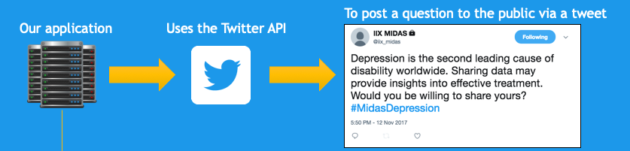

Figure 2.1 The Social Campaign Manager uses Twitter to consult public opinion

Alternatively, the SCM can be connected to an alternative direct messaging service e.g. Slack, Sametime, Facebook etc. To demonstrate how this could look and to also provide the logic that connects front with backend in the SCM a demonstrator generic chat window has been implemented. The window provides the functionality to implement a direct messaging service to ask and answer questions. This capability has been provided as a demonstrator without consideration of security, authentication or encryption that might typically accompany a direct messaging service. The reason for this is that the design and implementation of these features is heavily dependent on the system to which it is integrating and being deployed within and owner/user requirements. The application owner should consider and implement these requirements carefully for their use case of the SCM.

# Systems architecture­

## High level diagram

Figure 3.1 below is an architectural diagram of the SCM. Data analysis requires creating, running and maintaining a campaign.

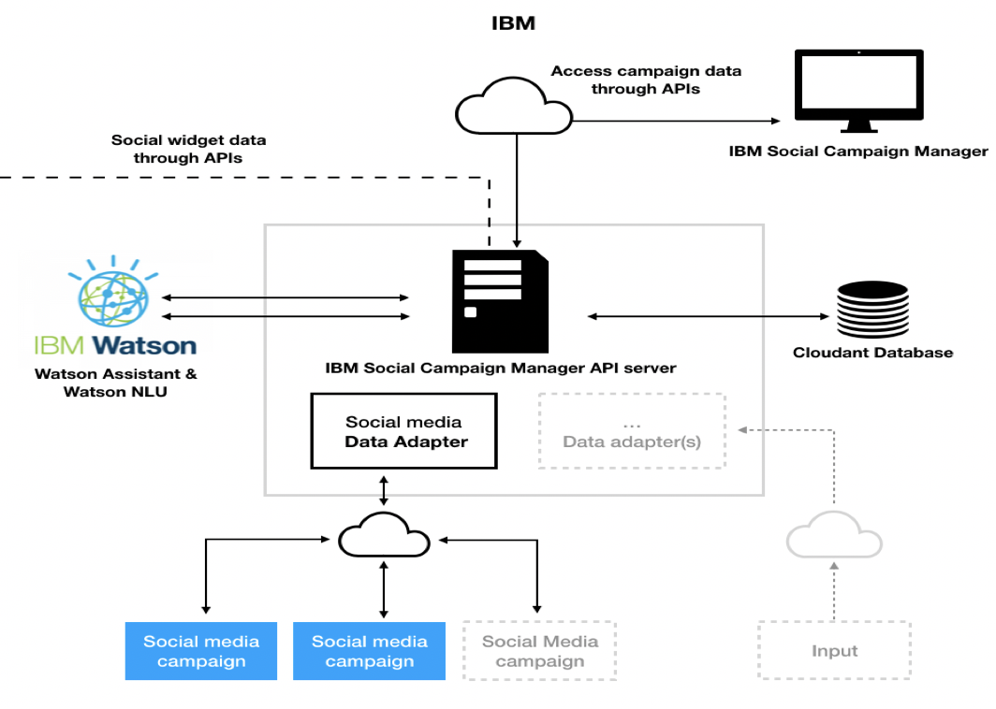

Figure 3.1 Social Campaign Manager – High-level architecture diagram

The other elements of the architecture will be discussed in the following sections.

## Adapters

The Social Campaign Manager API application service is built using a concept of data adapters. These adapters handle differences in the various social media APIs and transform the data coming from the various data sources into a common data model used by the platform. This allows the layers above to simply deal with the resulting data and not need unique logic for each platform. The Twitter social media data adapter is the first of a series of data adapters that can be implemented into the application. What’s worth noting is that a single social media adapter already provides an unlimited number of data inputs through externally facing campaigns.

The application also supports a direct messaging chat form prototype. The direct chat system is implemented in the same way as the twitter data adapter. The consolidated responses from all endpoints are displayed on the campaign dashboard.

## Watson

IBM’s Watson provides the cognitive and natural language services that run the chatbot and perform the analysis. Using the Watson provide the resources out of the box to build chatbots and analyse the responses that didn’t require training, experimentation, maintenance or developer operations (DevOps) to get up and running.

Two independent Watson services were used:

1. **Watson Assistant[1]** - Provides a web based GUI and API to allow the training of Natural Language Classifiers to determine a user’s “Intent” from their message. It also exposes a means to train a custom entity extractor, as well as having multiple in-built entity extractors for people’s names, locations, times, currencies, etc. mentioned in the text. Finally, it provides a means of constructing a dialog tree with each node representing a message from a user and a response to provide. The dialog tree leverages the intents and entities to determine which nodes are visited next, allowing the business logic of the conversation to be abstracted away from the server-side code. It is important to note that this kind of control using APIs is not usually present in other equivalents and is vital in the current social campaign manager use case.
2. **Watson NLU (Natural language understanding)[2]** - Watson NLU is a collection of natural language processing services wrapped under one umbrella, allowing them all to be performed in one request and to work in tandem. Inside the NLU the application uses:
   1. Sentiment analysis on the entire message.
   2. Emotion analysis on the entire message.
   3. 5 level taxonomy categorization on the entire message.
   4. Keyword extraction.
   5. Sentiment analysis on each keyword.
   6. Named entity extraction with optional disambiguation information if available.
   7. Sentiment analysis on each entity found.

## Alternative conversation assistant services

There are a number of solutions on the market today that work in similar ways that are both proprietary and open source. Open-source alternative solutions include Rasa, Botkit or Botpress. These specialised APIs would require a significant amount of resources to be manually built around these services. Some alternative services also require training after creating a conversation, which in case of the Watson Assistant Services is done automatically after a conversation flow is created.

## Watson Assistant Concepts

Here are four key concepts to understand before diving into the Social Campaign Manager’s campaign dialogs. Most virtual assistants (commonly called chatbots) use similar concepts to drive their behaviour. In Watson Assistant they are:

* **Intent**: An intent represents the purpose of a user's input. An intent is defined for each type of user request the application needs to support. Intents in Watson Assistant are prefixed with a # symbol, like in this example: #greeting.
* **Entity**: An entity represents a term or an object that is relevant to the intents that provides a specific context for an intent. Each entity and its values need to be listed in the tool together with synonyms the users might enter when talking about them. In Watson Assistant entities are prefixed with an @ symbol, i.e. @research_institutions. The tool also provides the user with a number of predefined *system entities* like a @number or @location to easily handle most common situations.
* **Dialog**: A dialog is a branching conversation flow that defines responses to the defined intents and entities. The creator uses the dialog builder in the tool to create conversations with users to provide responses[3]. A single assistant can have multiple skill dialogs associated with it.
* **Context Variable**: a context variable is a user-defined variable that can be used to direct the conversation or pass a value throughout the conversation. Some context variables might hold entities picked by the user, intents or just plain text used later in the conversation context. These variables are very useful for example when the user already gave an answer to a question that might be asked next. Context variables in Watson Assistant are prefixed with a $ sign, i.e. $is_why_question.

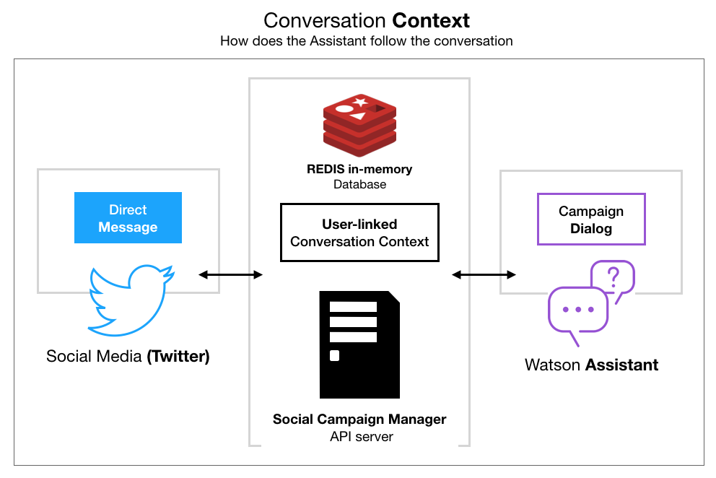

Figure 3.2 Conversation context is kept in an in-memory database

The context is how a campaign dialog navigates through the conversation (shown above in Figure 3.1). It is a JSON object with Watson Assistant system-related attributes i.e., which question node is the user currently answering. In the Social Campaign Manager, the dialog context is directly linked to the participant’s Twitter account using the user number of the account and saved in a REDIS in-memory database for quick access. This way the Assistant is able to continue the conversation even if the participant abandons the conversation for some time. A user context session is updated in the memory store every time the participant sends a message. It is programmatically set to last for 48 hours after the last update after which the conversation context is deleted by the database. If the participant wishes to talk to the dialog after it expires, the conversation restarts, which means they have to start the conversation from the beginning.

The above concepts are used throughout the SCM when building a social media campaign dialog. Each dialog employs all of the above concepts in a number of ways explained in section 3.1.5 Campaign Dialog Tree.

## Conversation Action Hander

The Social Campaign Manager (SCM) is an application built on top of two microservices. The web application, which the policy maker manages his or her social media campaigns, is connected to a service responsible for the REST APIs (Application Programming Interfaces), henceforth called the back-end service. REST, or REpresentational State Transfer, is an architectural style for providing standards between computer systems on the web, making it easier for systems to communicate with each other. REST-compliant systems, often called RESTful systems, are characterised by how they are stateless and separate the concerns of client and server.[4]

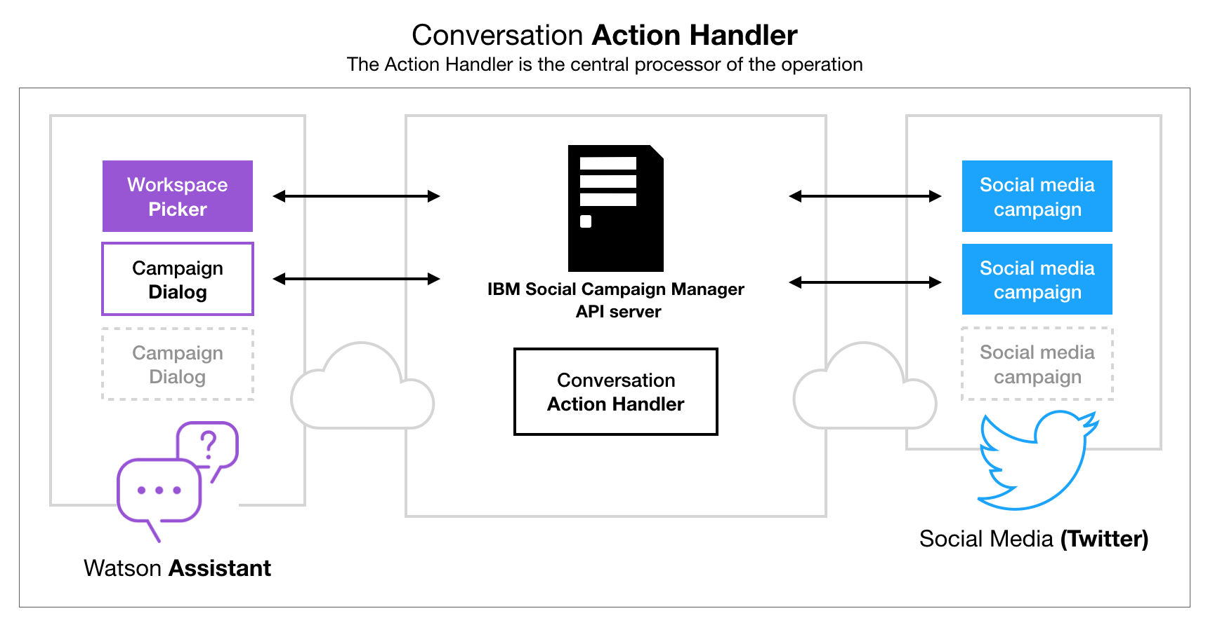

Figure 3.3 The Action Handler is where the conversation is processed

The back-end is powered with a multitude of data-providers interacting with services like the Watson Assistant for conversation capabilities or the Twitter service dealing with sending and receiving requests from social media. The integration of all these services is performed using an Action Handler shown in the middle of the diagram above in Figure 3.2**.** The Action Handler operates as the middle-man between the AI-powered dialogs and the user interactions on Twitter. It directs what action needs to be performed next using available providers. Social media interactions can be distilled into two categories: chat messages, where the user is chatting with the application through instant messaging (on Twitter called Direct Message or DM for short), and tweet activities – which are all other post specific actions like replies to tweets, liking, retweeting, etc. The Action Handler is able to distinguish between these types of activities and perform the required action. In case of a response to a tweet, the Action Handler replies to the potential participant with a link to a Direct Message conversation with the campaign the tweet is linked to in the SCM system. If the social media interaction turns out to be a DM, it processes the message accordingly. The message-processing flow diagram can be seen explained in detail further below.

The Action Handler also decides if the message needs to be analysed with a Natural Language Understanding service or saved to the database as a response to a campaign question. The system is also able to take into account a certain number of special commands. In this case the message does not need to be saved into the storage or analysed using the NLU service.

## Direct Message Processing Flow

Figure 3.4 (in landscape below) shows a use case diagram of the Social Campaign Manager’s chat capabilities. The study participant is able to send messages during the direct message conversation that don’t necessarily relate to the question on hand. These can be the:

* Basic special commands controlling the dialog - displayed in green in the diagram. Special commands are caught by the system which then does not send a request to the Watson Assistant Dialog.
* Results and Findings (in blue) calculated from the aggregated responses from the database. These show answers to the questions in aggregated percentage form and sentiment analysis for the whole campaign respectively. These are specific types of special commands. The user can ask for these in a multitude of ways therefore the Watson Assistant Dialog is required to mark them as #intents before the SCM server can provide the requested information.
* Questions about the campaign itself (in black), also referred to as the Required Questions**,** because they are required to be entered when creating a campaign.Each campaign needs to provide information on the data collected, consent, people to contact in case of further enquiries by the participant, etc. The participant can ask these at any stage of the chat. Answers to these questions come directly from the Watson Assistant Dialog.

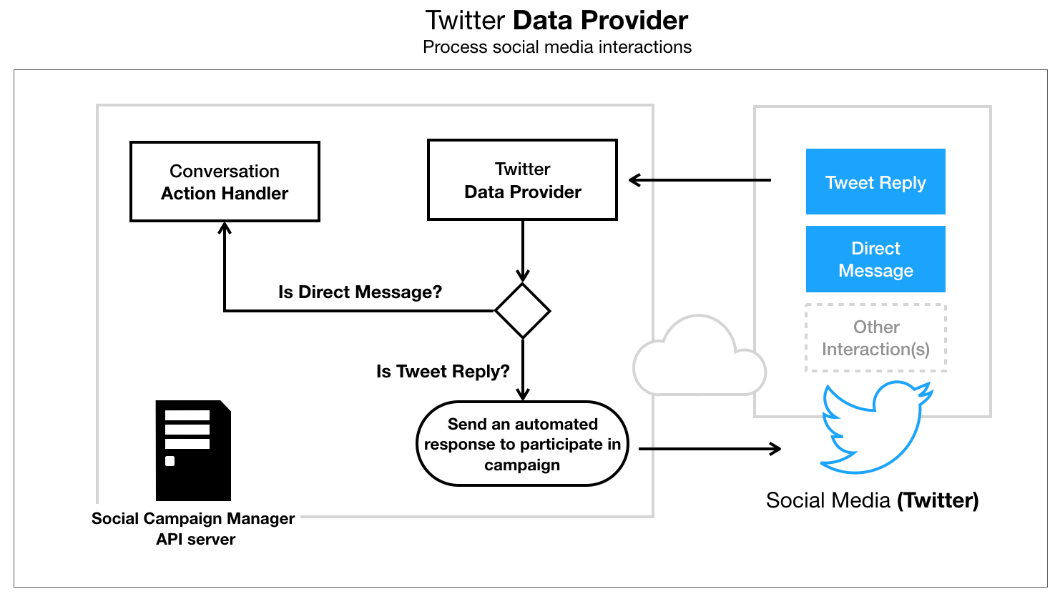

Figure 3.4 Twitter Data Provider automatically replies to tweets related to a social media campaign

The Social Campaign Manager uses the Twitter data provider to listen to requests from social media. Interactions like Direct Messages, Tweet Likes, Retweets, Mentions, etc. are processed by the server - see Figure 3.3 above.

If the interaction request is a tweet reply, the system sends out an automatic response to the person replying to the campaign tweet inviting them to participate in the campaign. If the interaction is a direct message it sends the message to the Action Handler to process its content. Otherwise, in case of likes, retweets, etc. – the interaction is discarded by the system.

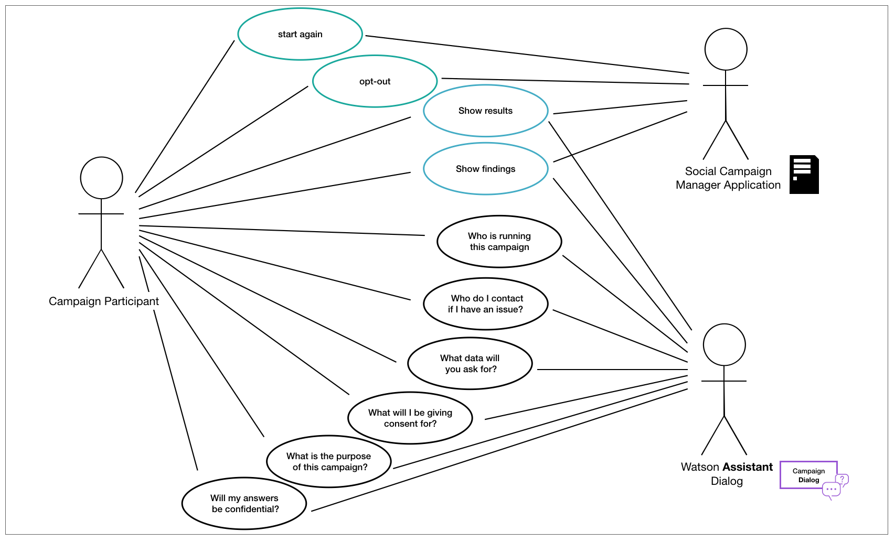

Figure 3.5 Use case diagram of optional in-chat capabilities of the SCM showing which actor is responsible for which capability

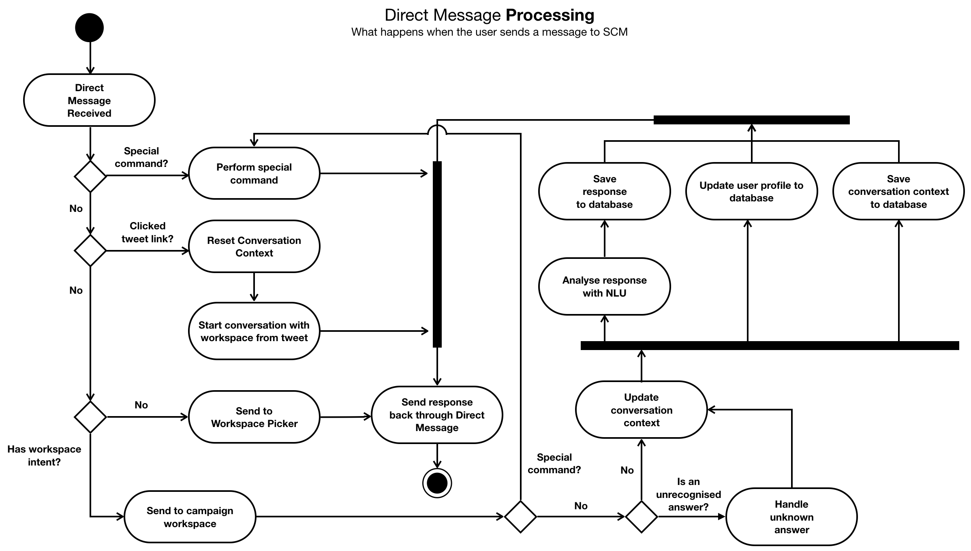

Figure 3.6 What happens when the system receives a Direct Message (DM) from Twitter

The dialog flow diagram in Figure 3.5 above describes the processes of reasoning which takes place whenever the system receives an instant message from a social media chat.

The Action Handler processes a Direct Message by first checking for the in-chat capabilities mentioned above. Before the message is sent to Watson Assistant, it is scanned for quick text commands like ‘start again’ or ‘opt-out’. Quick commands like this don’t need to be sent to the virtual assistant for processing. They are built-in server commands that handle application-wide commands like restarting the conversation. The ‘*start again’* command for example is a type of “hard reset” command destroying the conversation and letting the participant (or developer) start over in case the dialog runs into an infinite loop. The *opt-out* command marks the user’s conversation for deletion if the member of the public would like to withdraw consent to their collected data.

A Direct Message is a JSON Object sent by the Twitter SDK which holds a number of attributes. One of the attributes is the link the user clicked to start the conversation. This link attribute is used to associate a message with a particular social media campaign. If this happens, the conversation is restarted, and the conversation is automatically linked with the correct Watson Assistant Dialog without the participation of the Workspace Picker. The Workspace Picker will be explained in detail in section 3.1.4 Workspace Picker.

Messages are then sent to the appropriate dialog skill in the Watson Assistant system. The dialog replies with a message containing:

* A raw text response
* context: this is where all of the up to date conversation context like recognised #intents, @entities or $variables are kept
* dialog nodes:a dialog node is a certain place in the conversation. This attribute can be used to manipulate the dialog programmatically from the server-side.

Based on the context attributes of the response message, the system decides what is the next appropriate action. In case of a recognised special command the command is performed immediately, after which the system responds to the participant with the appropriate response.

The dialog message coming from the Assistant will generally be either a question or a request to the user to provide some information. The dialog is usually a one-to-one question answer exchange. Sometimes though, the user types in an unexpected response or decides to ask a question in response to a question instead of giving a straight up answer. Luckily, Watson Assistant has a built-in intent feature called #anything_else. Using this intent in conjunction with context variables the chatbot is able to catch unrelated responses or as in the above diagram, unrecognised answers. Both recognised and unrecognised answers update the message context, however they end up stored in their own respective places in the database for further analysis by the researcher studying the campaign.

Determining the type of answer leads to the system performing semantic analysis on the content of the raw text sent earlier by the participant. The text is analysed with a Natural Language Understanding (NLU) service to determine the sentiment and the emotional composition of the message. The NLU is able to determine with confidence what levels of joy, sadness, fear, anger or disgust are present in the participant’s answer and provide confidence levels deciding if the message is generally positive, negative or if it is neutral.

The participant’s response together with the NLU results are then saved to the database and displayed as graphs in aggregated form on the Campaign Detail Page and in the social media widget present on the Midas UI Dashboard. More detailed information on the keywords, categorisation and mentions of entities present in the text are shown on the Campaign Detail Page.

The system also updates the user’s context in the REDIS database and the participants profile in the system’s database, if required, in parallel to speed up the bot response process. The profiles database collection holds information if the conversation has been concluded, what is the participant’s estimated location and basic profile and demographic information.

## Workspace Picker

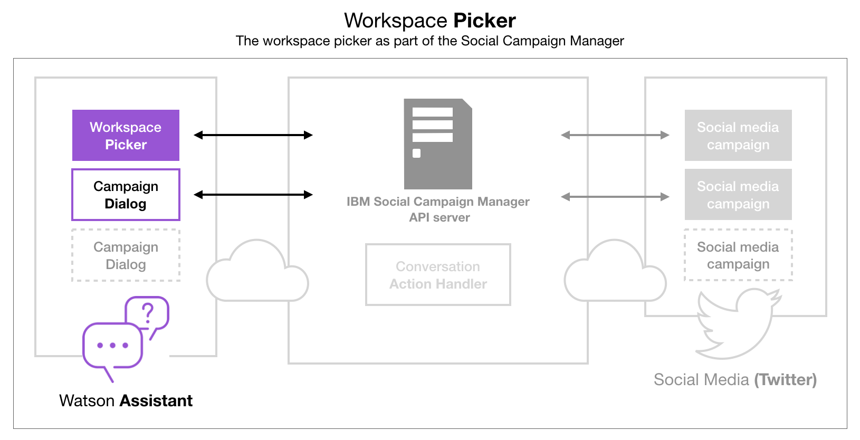

Figure 3.7 Workspace Picker is a special type of Watson Assistant Dialog

The Social Campaign Manager uses Watson Assistant dialog skills to perform operations based on the participants’ actions; each campaign therefore is a dialog. The Workspace Picker (shown in context in Figure 3.6) is also a dialog skill. It is updated every time a campaign is created or deleted. The reason for this is to let a single Twitter account hold multiple campaigns at a time. If a person decides to message the account directly instead of clicking a link in a tweet, it decides which social media campaign the participant participates in. The Workspace Picker links the currently available campaigns with its own intents. Each campaign therefore can be selected by the user in a free form conversational way. Every instance of a Social Campaign Manager needs to have a single Workspace Picker. This way the system always knows which campaign dialog the participant is going to talk to.

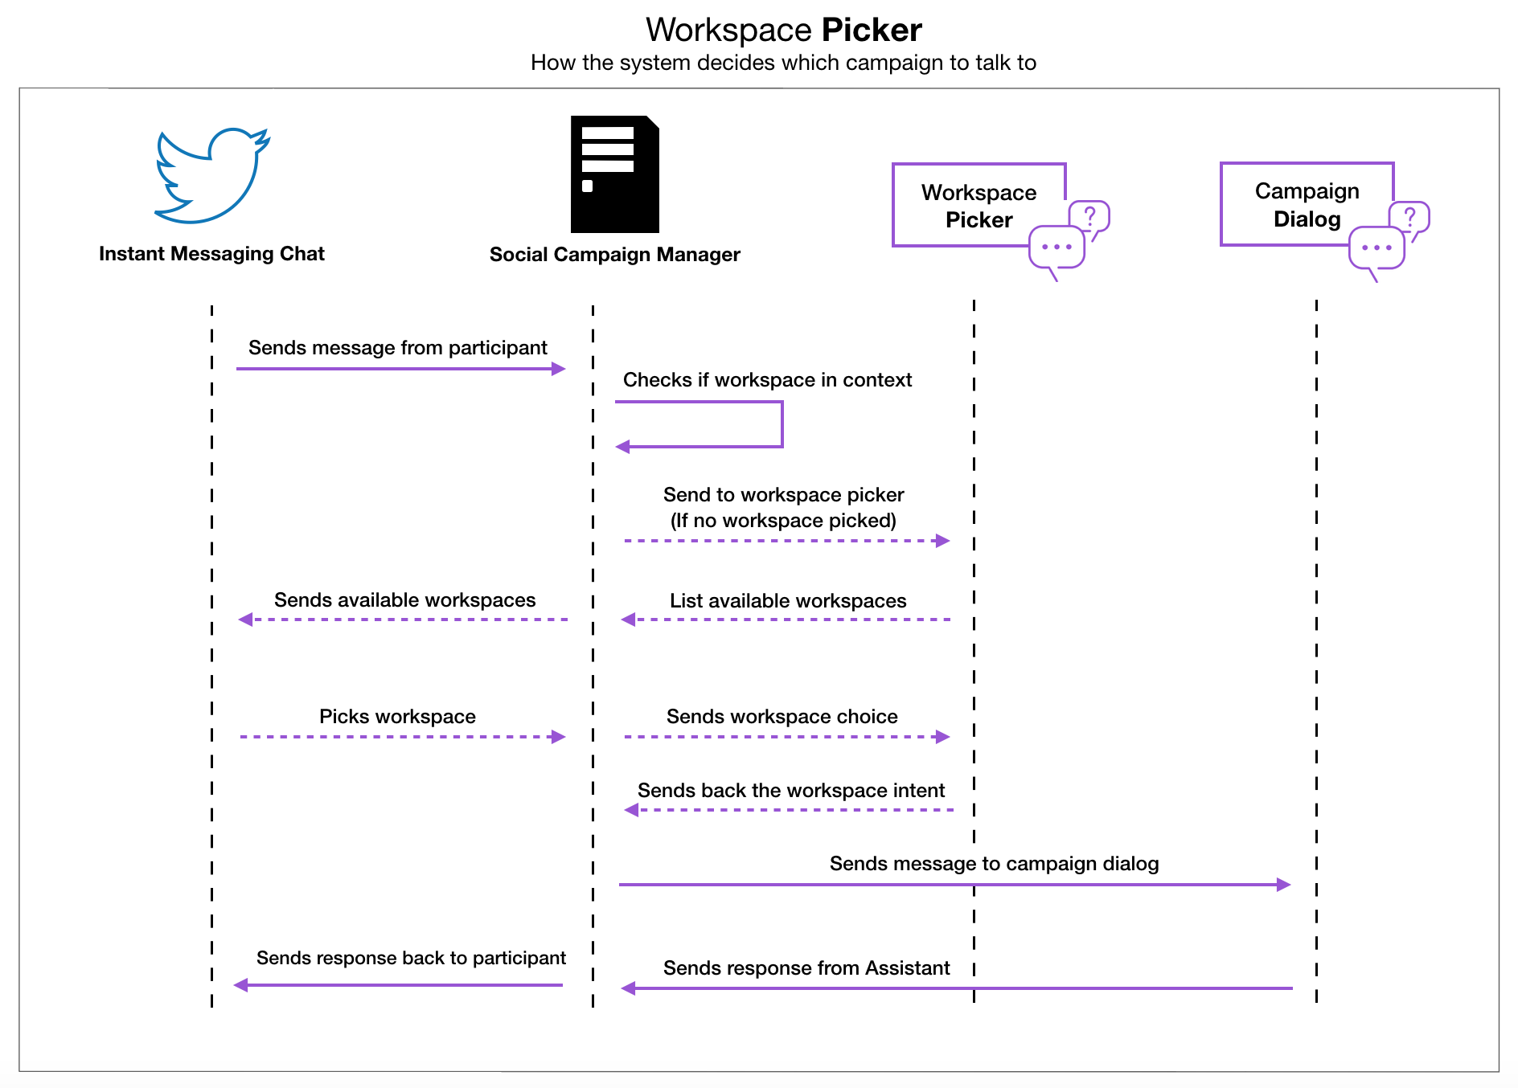

Figure 3.8 Use case diagram of the Workspace Picker decision making

The above diagram (Figure 3.7) demonstrates what happens when the Social Campaign Manager receives a message. Each time an instant message is received, the SCM checks the user context database for an existing dialog context. The system looks for an existing campaign intent linked to the Twitter user number. If the context does not exist in the memory store, the SCM sends a message to the workspace picker to list out the currently available campaigns (workspaces).

Once the user picks a campaign the Workspace Picker sends appropriate intent confirmation to the Social Campaign Manager back-end server. The SCM then starts the conversation with the appropriate dialog skill.

## Campaign Dialog Tree

Creating a social media campaign in the Social Campaign Manager creates a skill (also called a workspace) in Watson Assistant. A skill is made up of intents, entities and a dialog. The dialog is displayed in a form of a tree containing nodes directing the conversation with the aid of intents, entities and context variables. Figure 3.8 below demonstrates a basic representation of a typical dialog tree found in the SCM. The conversation begins with the conversation assistant sending a welcome message to a campaign participant. After that the consent question and the demographics question and finally the campaign questionnaire starts.

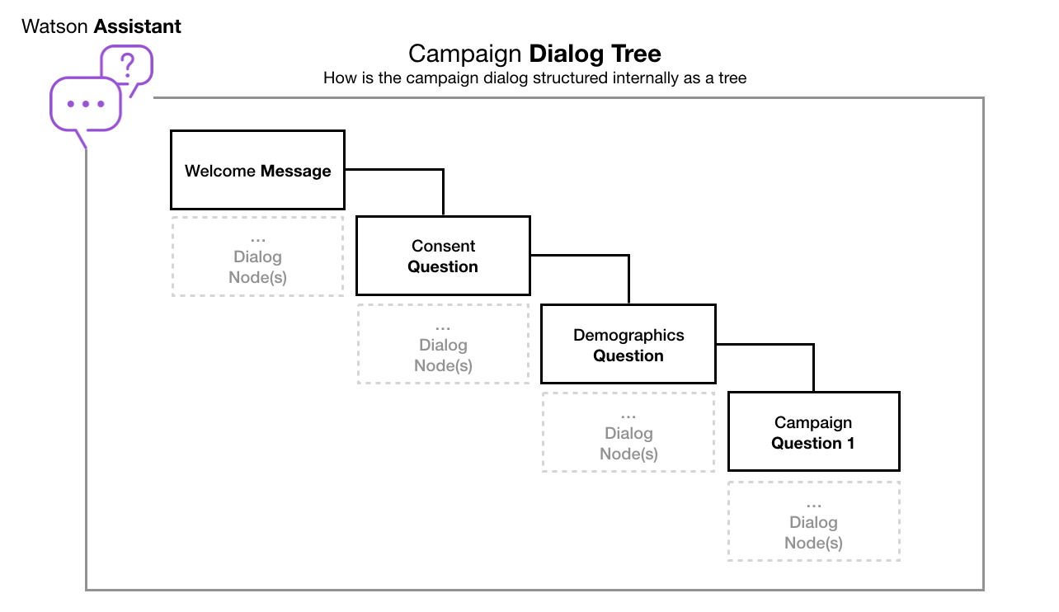

Figure 3.9 A simplified representation of the campaign dialog tree

The dialog starts off by displaying a welcome message to the participant with a pre-defined greeting and consent message. The welcome message uses a context variable **$name** which is defined when the participant first messages the SCM from Twitter. The system uses the name found in the participant’s user profile to personalise the response as seen in Figure 3.9 below.

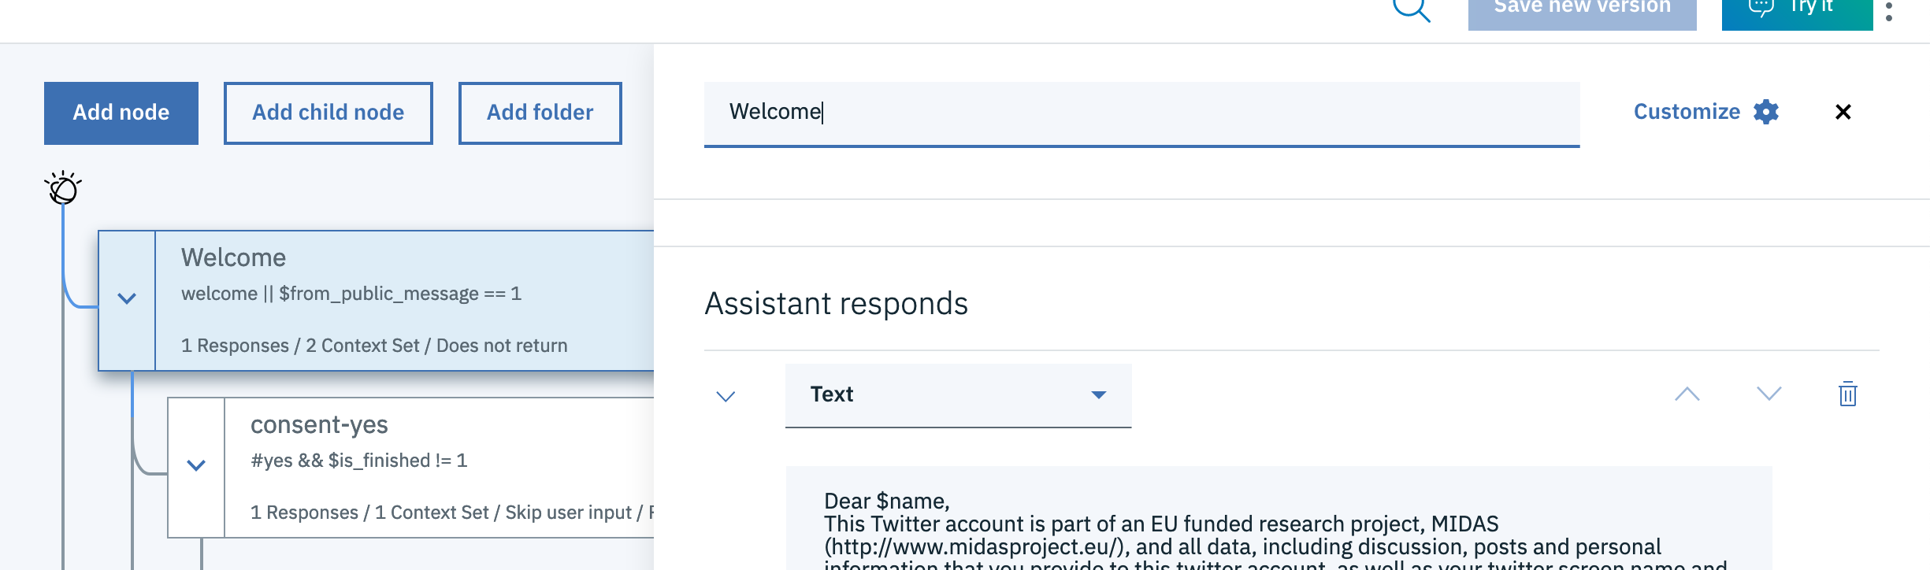

Figure 3.10 Watson Assistant Welcome Message

The welcome message will be sent to the user if the assistant recognises the intent to **#welcome** or if the context variable **$from_public_message** is populated by the system. This variable is set to 1 when the participant clicks the link in a tweet mentioned in 3.1.3 and in the message processing diagram in Figure 3.1.

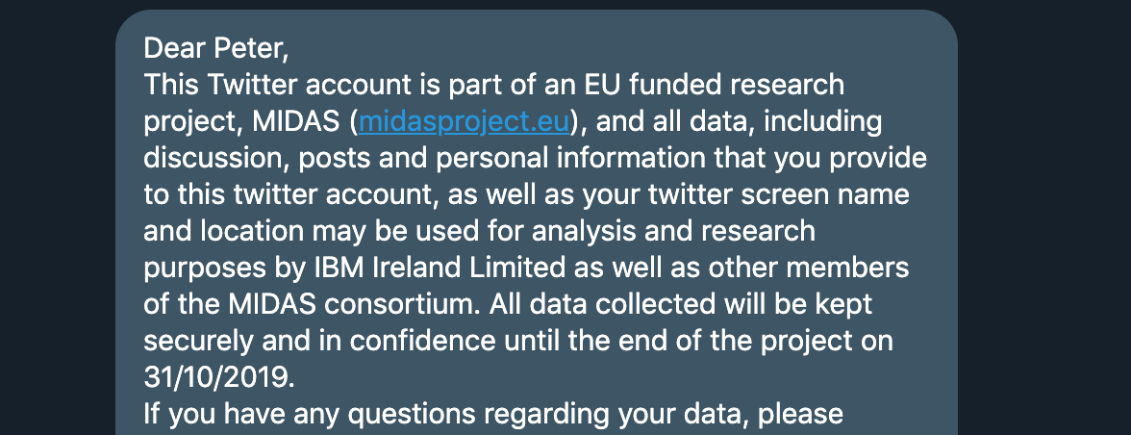

Figure 3.11 Twitter direct message with name variable populated

Each node continues on to its following child node, if any are present. Otherwise it stops the dialog conversation on the level it is at and listens for the user input before continuing. Dialog nodes can also be made to stop and listen for user input before continuing at each internal level. This is where the dialog looks for intents, entities and context variables to decide which child node to process next. The first example of this is the Consent Question displayed in Figure 3.8 above. The consent node passes on a question asking the study participant to agree or disagree with the terms and conditions of the study. It is followed by two children nodes, one of which looks for an intent to agree and the other looks for an intent to disagree. An example of an intent to agree would be the participant replying with “I consent” or saying “yes”. The dialog node which looked for the intent to agree then continues on to its child node which asks for demographic information. The dialog node which looked for the intent to disagree sends the user an appropriate goodbye message and marks the conversation as finished using a context variable. This context variable then lets the system know that the user has already participated in the study, therefore does not continue to the campaign questions.

Figure 3.11 below expands the previous diagram (Figure 3.8) by showing the dialog in more detail.

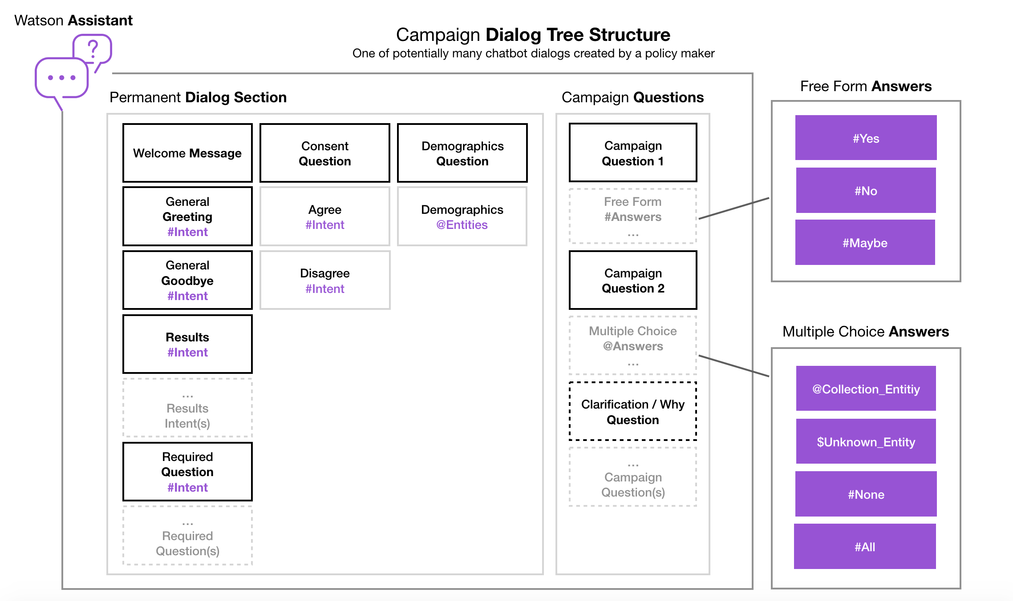

Figure 3.12 More detailed Campaign Dialog Nodes Structure

Each social media campaign is always created with a permanent dialog section and a Campaign Questions section as shown in the diagram. The permanent section provides the base skeleton structure of the conversation. It also does not require much of the campaign owner’s input beyond filling in the *required questions.* These being a set of dialog nodes providing information about data privacy, contact information, the campaign owner, etc., created in the main level of the conversation, thus being accessible from any part of the conversation. In the same line as the required questions, the dialog contains the general greeting and goodbye nodes which handle the campaign participant saying ‘hello' or ‘bye’. The permanent section also includes nodes which handle intents about the results or findings. These dialog nodes tell the system that the person requires information about the answers given by other participants. The system passes the intent to the back-end service which replies to the participant with a brief summary of the results or a semantic analysis of the study respectively.

The Campaign Questions section is a dynamic set of nodes where the majority of the conversation is carried out. This section is handled as a child of the demographics dialog node. The number of intents and entities varies here depending on the amount and type of questions.

There are three types of questions available for the policy maker to create in the system:

* Yes / No / Maybe questions
* Multiple-choice questions based on entity collections
* Free Form – taking advantage of the #anything_else intent

In a Yes/No/Maybe question the child dialog nodes are looking for the participant to answer the question with an intent that could be taken as a ‘*yes’*. People communicate in quite a fluid language. A **#yes** intent can be expressed in many ways, for example: ‘*yeah*’, ‘*ya*’, ‘*yeh*’, ‘*uhm*’, etc. All these expressions can be understood by the chatbot as a person trying to state an intent to confirm or agree to something. Similarly, this is repeated in the other two intents **#no** and **#maybe**. In this case the dialog nodes would listen for the user disagreeing with a statement or not being sure how to answer with a ‘*perhaps*’. Multiple-choice questions look to satisfy a more complicated set of conditions.

The first child dialog node looks for a collection of entities created by the campaign owner. As previously described in section 3.1.1: “*An entity represents a term or an object that is relevant to the intents that provides a specific context for an intent.”.* In the SCM answers to multiple-choice questions are grouped into collections of entity values. The creator of the campaign gives the collection a name to be used later in the application. Below Figure 3.12 shows an example of a multiple choice question in the Social Campaign Manager. The researcher creating the campaign lists answers to be used in a multiple-choice question. Synonyms in the examples section are words a participant can use during the chat to select this option, in the example below – “Culture” will be selected even if the user makes a spelling mistake, like ‘cultre’, or ‘kultur’. Examples could also be words that are related to the option itself for example ‘cinema’ or ‘art’ as they are part of the topic discussed in this campaign – culture.

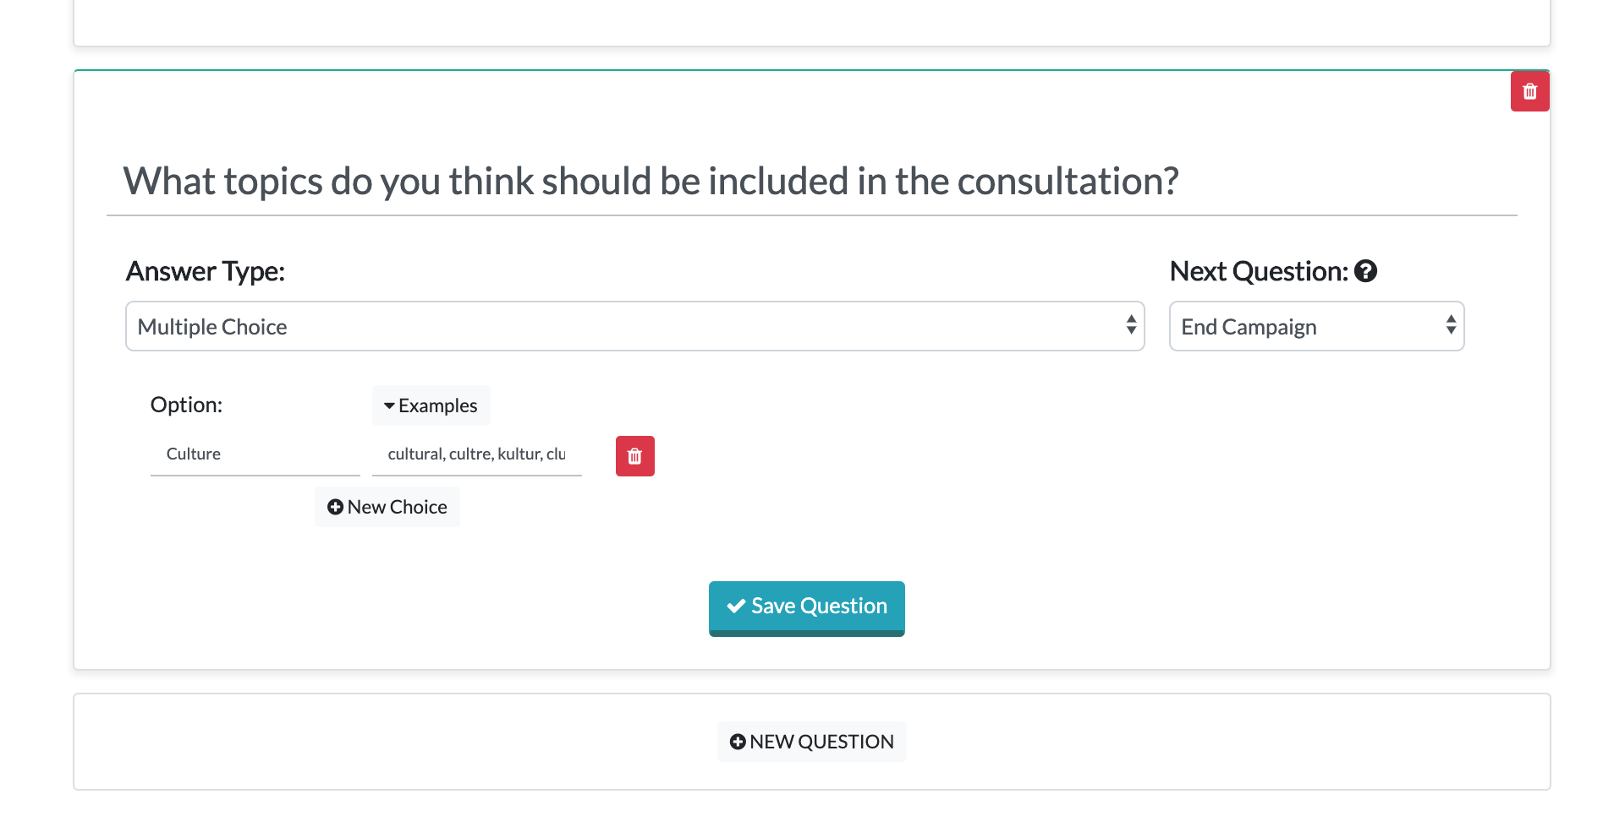

Figure 3.13 Multiple-choice question option in SCM

When creating the entity in Watson Assistant, the system appends a random suffix to the name in the background in case it was being repeated or used by the system already (for example, a system entity “sys-number” is a restricted entity name). Figure 3.13 demonstrates an example of an entity created in WA. The question in an example campaign asks which topics would be interesting to consult the public on. The tool finds synonyms for the selected option and populates the appropriate entity values.

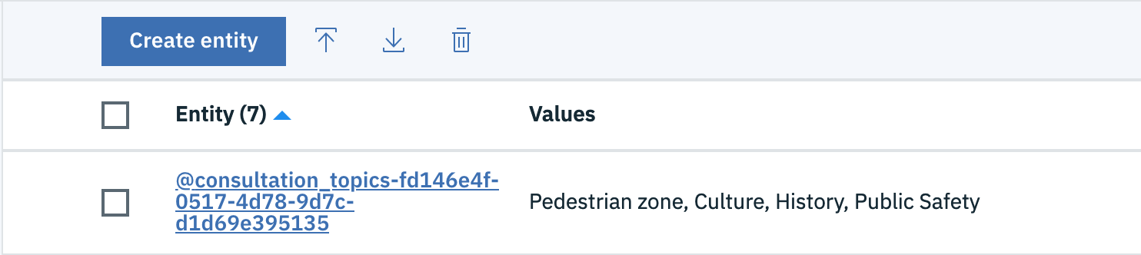

Figure 3.14 A list of multiple-choice answers as entities in Watson Assistant

Figure 3.14 demonstrates the synonyms from the SCM tool as they are displayed in the Watson Assistant entity details section.

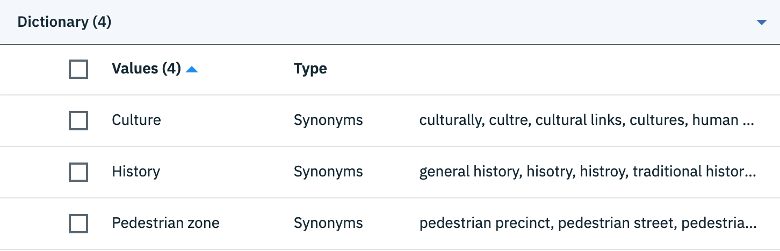

Figure 3.15 Multiple-choice answers are entity values with synonyms

The second child dialog looks for a context variable $unknown_entity. The unknown entity in this case is the participant’s answer not recognised by the Assistant as part of the previously described entity collection but found to be also related to the collection. Each answer to multiple-choice questions is being analysed with an NLU service which provides categories, entities and keywords in the response text. Entities found in the response are compared with saved answers to the multiple-choice question.

Further intents use two of the system entities available through IBM Watson Assistant:

* **#All** – selects all the answers from the list
* **#None** – selects none of the answers from the list and moves on to the next question

It is possible for a multiple-choice response to be followed-up by an optional ‘Why question’. This clarification question expands the participants answer and analyses the text with a Natural Language Understanding service. This is where the most valuable text analysis is done. The NLU services usually need a piece of text to be of a certain length for the analysis to be relevant and useful. When the participant writes a longer reply clarifying their answer the NLU provides its best results.

## Data Persistence

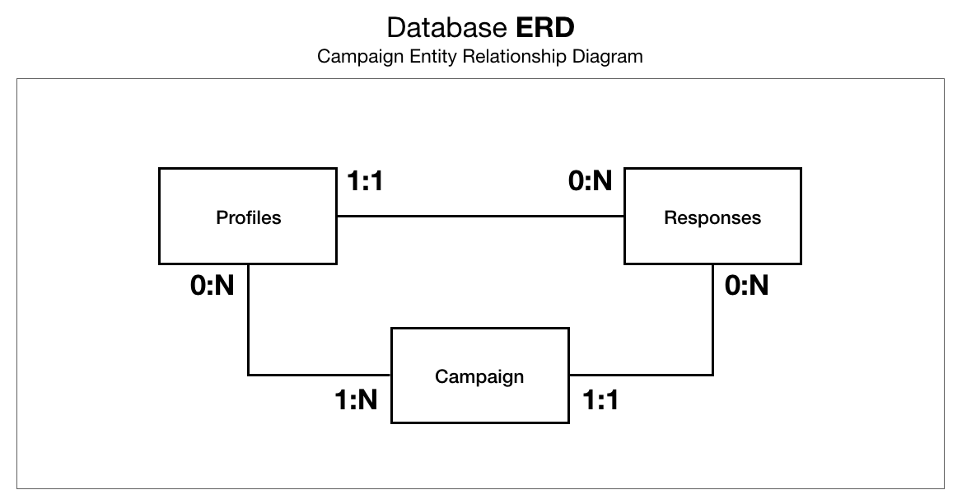

Figure 3.16 Database Entity Relationship Diagram

The Social Campaign Manager stores data in IBM’s Cloudant NoSQL database[5], which is a distributed, cloud native, maintained version of the open source database technology CouchDB, and fully compatible with CouchDB. Figure 3.15 above shows an Entity Relationship Diagram of the data stored in the SCM.

There are 3 conceptual *databases[6]* designed to store data associated with the application:

1. **Campaigns**  
   The campaigns database stores one document for each campaign created using the dashboard.
2. **Profiles**Each social media user who responds to the chatbot and consents to having their data recorded, gets an entry in the profiles database. Each document in the profiles database will also keep track of which campaigns a user has started and / or finished.
3. **Responses**  
   Each user generated message to the system (e.g. Tweet, Reply, Direct message, comment, instant message, etc.) will result in one document being stored in the Responses database. Each document will contain the user id of the user who sent it, the raw text of the message, annotations from Watson Assistant (e.g. is the message a response to a multiple-choice question, list of multiple-choice answers supplied, demographic answers extracted etc.), annotations from Watson NLU (e.g. sentiment, emotion, keywords etc.), the campaign ID and some of the data coming from the social media API.

## APIs

Data displayed on the dashboard comes from a number of Application Programming Interfaces (API’s) IBM have developed. The APIs are used by two applications. One is the Social Campaign Manager front-end application displaying campaign data, used to control social media campaigns. The other is a Dashboard social widget which displays a shortened view of the campaigns.

|  |  |  |  |
| --- | --- | --- | --- |
|  | **/campaign** | Will return a list of campaigns in the database, with their id, name, created date and the description created for the campaign. | |
|  | **/campaign?campaignId={xxx}** | Will return the full data contained for the given campaign.  Attributes include:   * id – campaign Id * _rev – revision, used to save in Cloudant and display version on edit page * Name – campaign name * Description – campaign description * consent_message – privacy policy and consent form statement starting each campaign * required_questions – all required governance questions like “Who is running this campaign?”, etc. * status – campaign status (Draft, Running, Stopped) * questions – campaign questions array * picker_intent – workspace picker intent * picker_intent_example – workspace picker intent examples * twitter_initial_tweet – initial tweet text * twitter_initial_tweet_id – initial tweet id * twitter_hashtag – hashtag used in twitter campaign * twitter_initial_tweet_link – link to initial tweet to be displayed on edit page * chat_introduction – first chat message introduction after consent form agreed to by the participant * language – campaign language * watson_workspace_id – Watson Assistant workspace (skill) id * watson_workspace – Watson Assistant workspace object (saved after posting to Watson) * created – date created * created_by – created by user id * updated – date of last update * updated_by – updated by user id * published – published date * published_by – published by user id | |
|  | **/campaign-draft** | Expecting a ‘campaign’ json property in the body, will create the given campaign draft. Requires just the minimal campaign data name and description. Creates the campaign full body. | |
|  | **/campaign/publish** | Expecting a ‘campaign’ json property in the body, will generate a new campaign dialog based on the current campaign questions, create a Watson Assistant skill, update the Workspace Picker intents and save the campaign to the database. | |
|  | **/campaign/save** | Expecting a ‘campaign’ json property in the body. Saves the campaign to the database but does not publish to Watson Assistant. | |
|  | **/campaign** | Expecting a ‘campaignId’ and ‘campaignRev’ (revision (aka version)), will delete the associated document version. | |
|  | **/campaign-participants?campaignId={xxx}** | Will return a list of participants with the following attributes:   * socialMediaUserId – participant identifier * age – participant provided age * gender – participant provided gender * locationName – participant city / town * locationData – participant city with gps coorinates * campaigns – campaigns this participant engaged with | |
|  | **/campaign-tweets?campaignId={xxx}** | Will return a list of participants with the following attributes:   * socialMediaObjectType – tweet * campaignId – campaign identifier * timestamp * nlu - Natural Language Understanding results, providing semantic analysis, emotions, keywords, entites and entity mentions * language – campaign language * rawMessage – raw message text * twitterThreadId – twitter thread id – initial campaign tweet number | |
|  | **/campaign-responses?campaignId={xxx}** | Will return a list of participants with the following attributes:   * campaignId – campaign identifier * socialMediaObjectType – direct-message * socialMediaUserId – participant identifier * rawMessage – raw message text * location – city / town of participant * timestamp * dialogNode – question being answered * nlu – Natural Language Understanding results, providing semantic analysis, emotions, keywords, entites and entity mentions * language – language of the campaign * isUnknownResponse – flag if unusual response * recognisedPredefinedAnswer – Watson recognised intent / entity values (for example multiple choice answers or yes/no) | |
|  | **/campaign-results/widget** | | A consolidated version of the campaign results and semantic analysis to be used in a website embedded widget. Showing the tone and general semantic view of the campaign. |

# Demo

## Social Campaign Manager

This section will demonstrate typical use cases for the Social Campaign Manager. It shows how to create, edit and delete a social media campaign and what the various results on the campaign dashboard mean.

### Creating a campaign

First step, as shown in Figure 4.1, is to create a campaign by giving it a name and description.

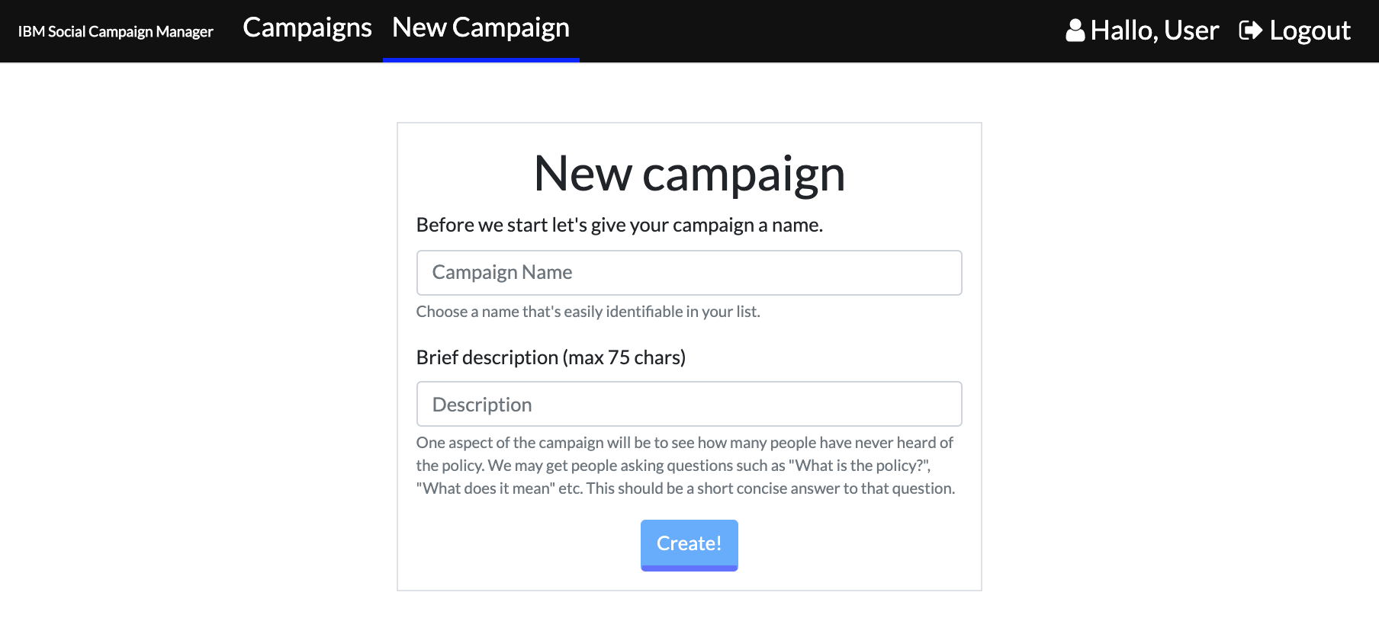

Figure 4.1 Create a draft campaign

After creating the draft the campaign will be ready to be filled with content.

Figure 4.2 Campaign creation – Campaign questions

The campaign owner can start creating the questionnaire in the Questions sections straight away in the as seen in Figure 4.2 These questions and answers are data needed to implement Yes/No, multiple-choice and freeform questions feature.

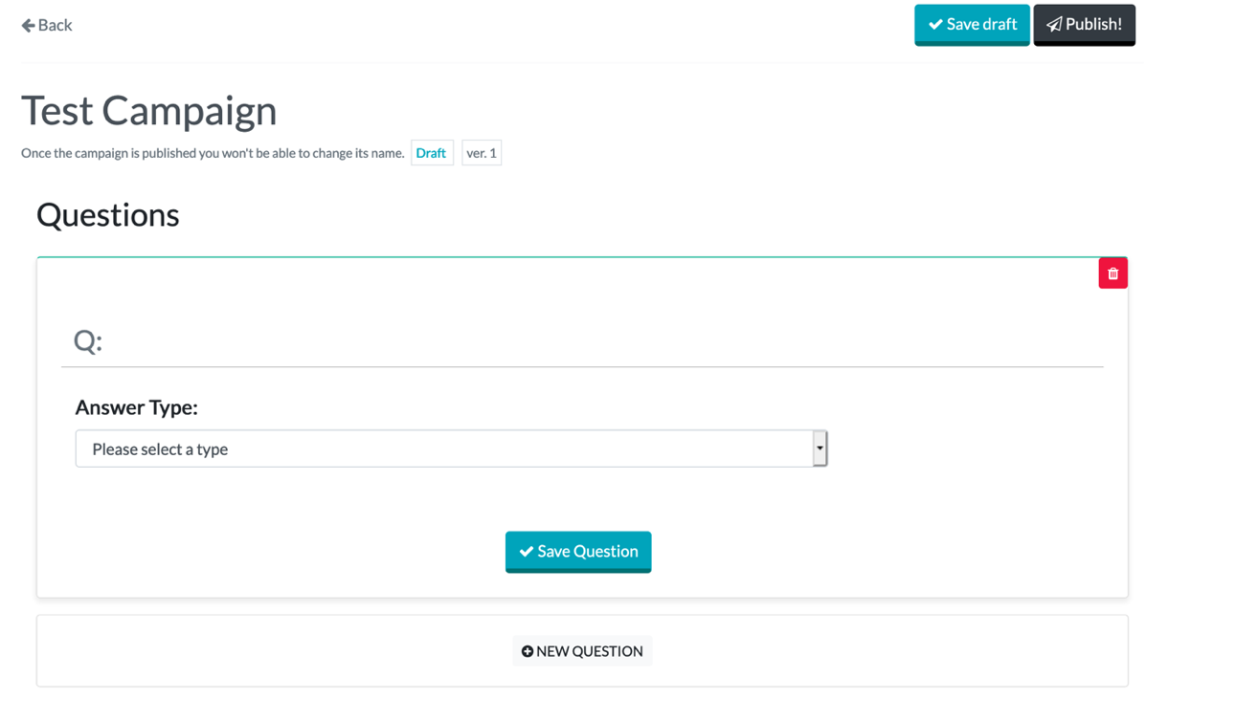

Figure 4.3 Campaign creation – Adding questions and answers

Next, in Figure 4.4 the campaign owner is presented with a screen with a set of default questions that users may ask the chatbot at any given time. These default questions are based on frequently asked questions from the trial campaigns. As an example, when asking for the user’s consent, the user may ask “who is running this survey”. This screen allows policy makers to provide answers to these questions for the chatbot to answer on their behalf. These questions are always present for every new campaign.

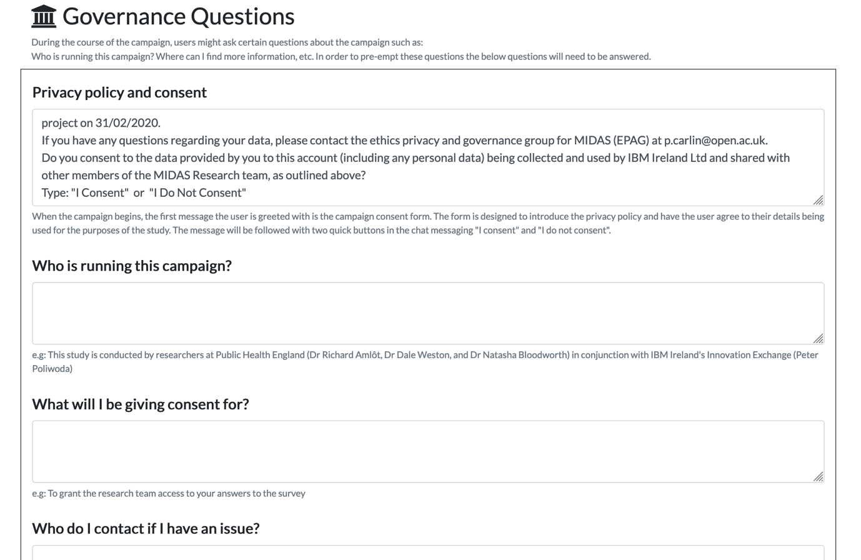

Figure 4.4 Campaign creation – Providing answers to default questions around consent

Figure 4.5 allows the user to enter an introduction message. This Campapign Chat Introduction is displayed to the participant after they consent to the privacy statement. This can be a simple explanation of the campaign or a further detailed message directed at the user. This section also displays the campaign description. It will be displayed in the list of campaigns together with their names if engaging with the chatbot without specifying the campaign first. For example messaging the Twitter account or going to the /chat path without specifying the campaign id number.

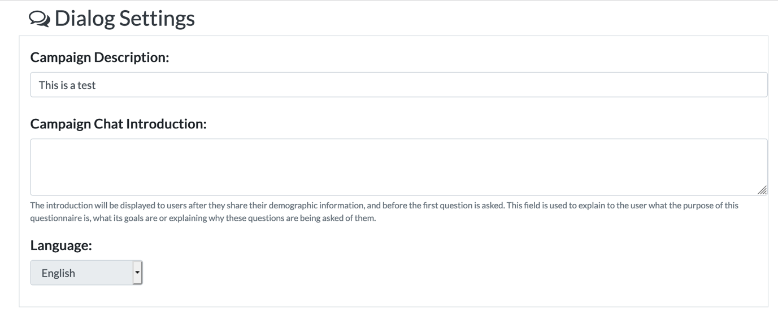

Figure 4.5 Campaign creation - step 4 – Creating campaign questions

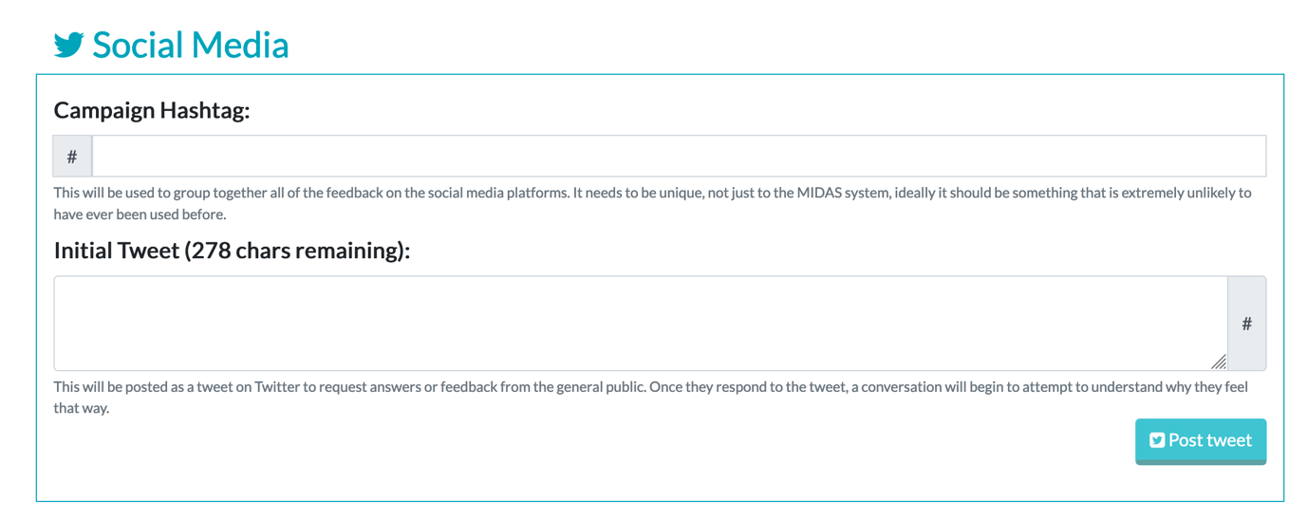

Figure 4.6 Post Tweet and/or Publish Campaign

Lastly in Figure 4.6 there is a screen where the campaign owner can post a tweet to social media and or publish the campaign. Posting the tweet will send a tweet out from the host twitter account provided during setup of the SCM. Publishing saves the campaign and is used to update the campaign if edits are made. These are two separate and distinct actions.

### Engaging with the public

Once the campaign is created the system will send out a Tweet for members of the public to see and reply to. Once they reply, the bot will ask them to speak privately in direct messages.

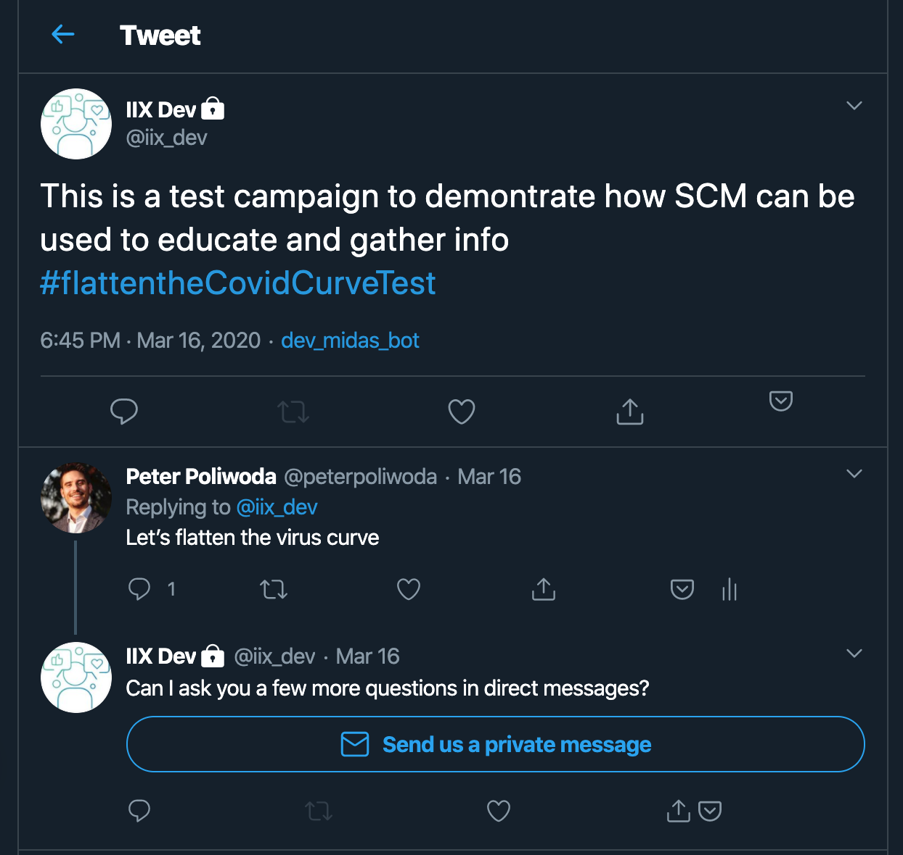

Figure 4.7 A user being asked to speak in direct messages after reply to the bot

Once in direct messages, the bot will ask for the user’s consent to have the questions recorded and ask them for some demographic answers. Once complete the chatbot will give the user some context and begin asking them the questions supplied as seen in Figure 4.8

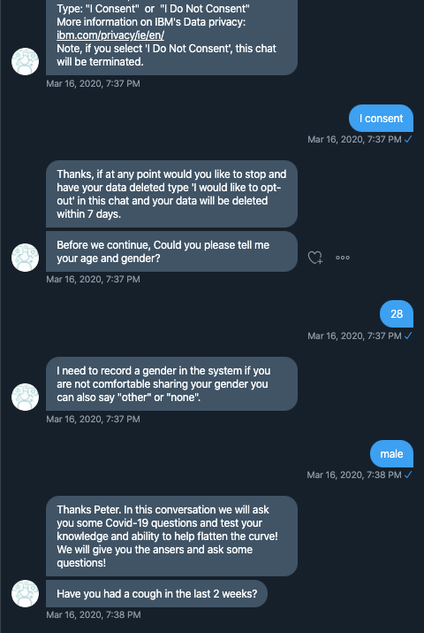

Figure 4.8 A direct message conversation with the chatbot

### Viewing the results

The results can be viewed at any time during the campaign. All the analysis is performed in near real time and only takes a few moments for the data to become available.  
  
Logging into the dashboard and selecting the campaigns tab, as in Figure 4.9, the policy maker is presented with a list of all available campaigns.

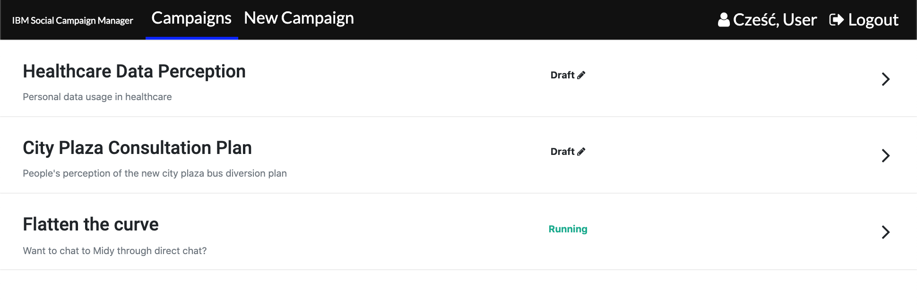

Figure 4.9 Social Campaign Manager dashboard viewing list of campaigns

Selecting one of the campaigns will bring the user to the results page, initially showing the overall summary of the sentiment and emotion as seen in Figure 4.10, alongside some basic metrics. Scrolling down the campaign owner is shown the demographics of users who provided answers to this social media campaign, including attributes extracted from their twitter profiles, such as location in Figure 4.11.

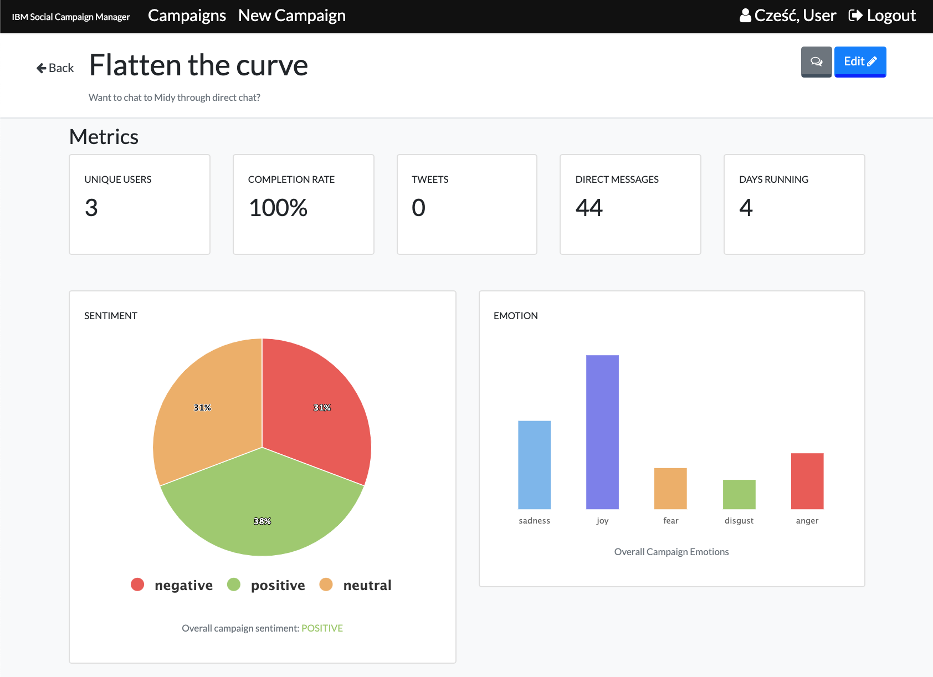

Figure 4.10 Social Campaign Manager dashboard viewing summary and metrics

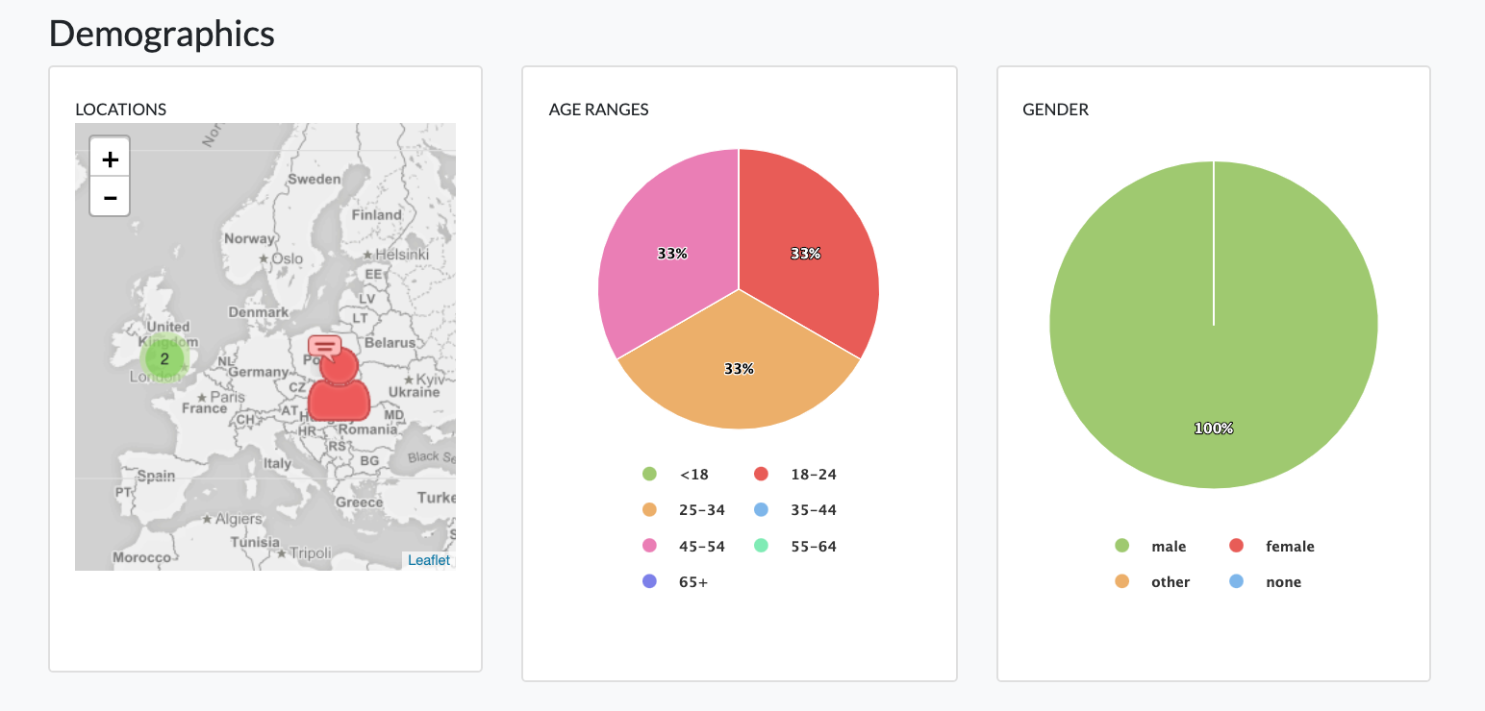

Figure 4.11 Social Campaign Manager dashboard viewing demographics

Further down the dashboard the results of all the analysis performed are gathered by Watson and are subsequently aggregated into a chart for each question. The chatbot received all the answers as freeform text, but the natural language processing services have been able to extract the meaning in a way that allows us to deliver the same style of results you will find in other online survey tools. Figure 4.12, Figure 4.13 and Figure 4.14 show results of three styles of questions. Yes / No / Maybe, multiple choice and a free form open text answers.

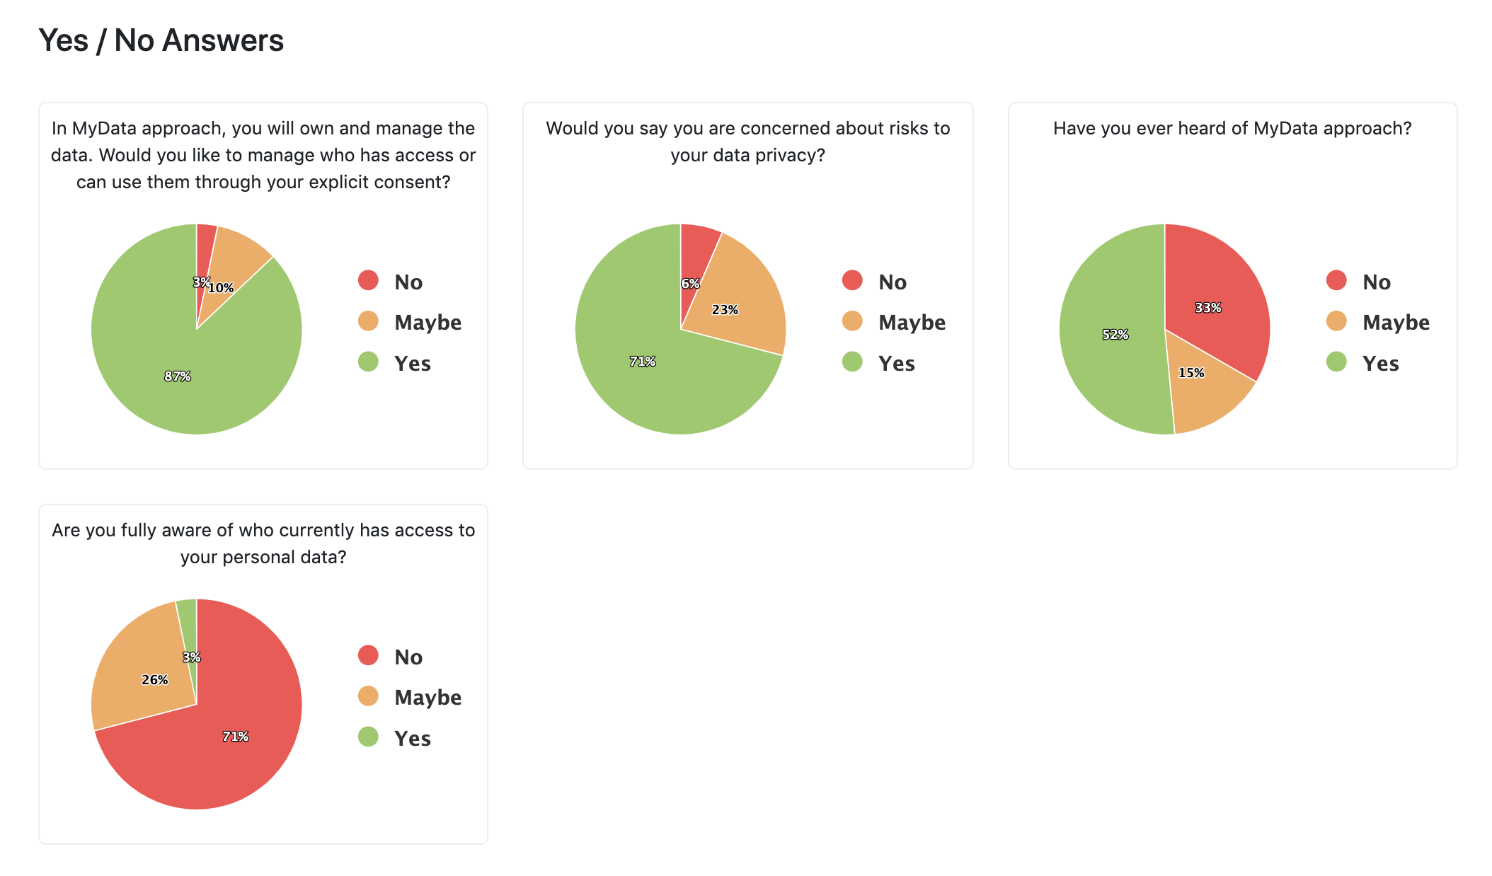

Figure 4.12 Social Campaign Manager dashboard viewing question answers

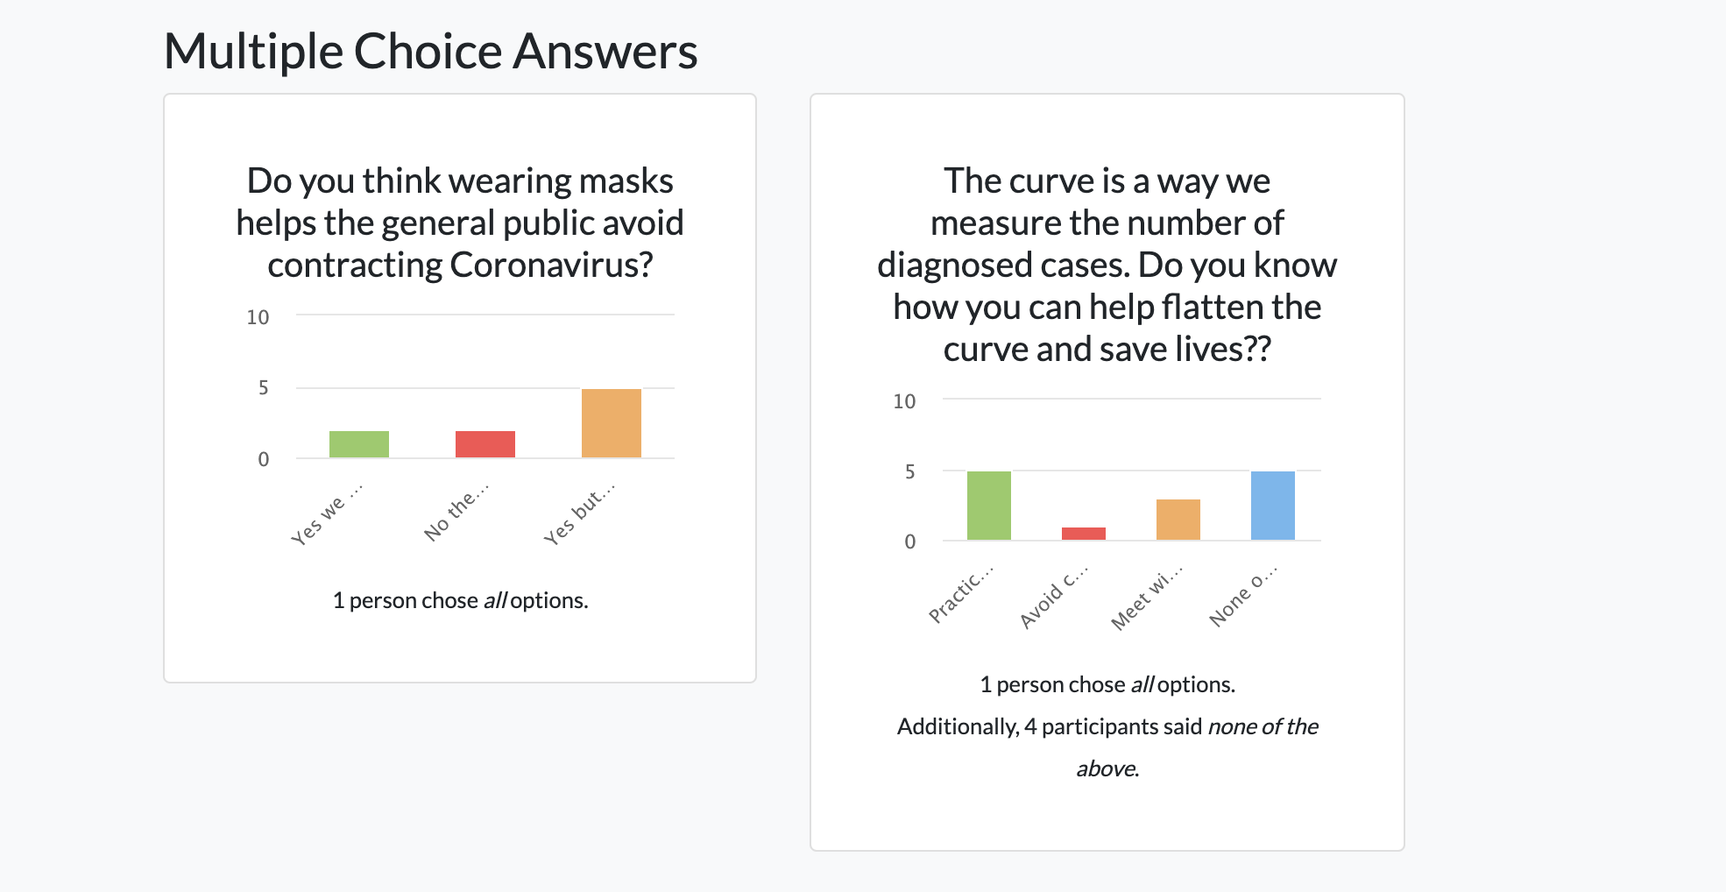

Figure 4.13 Social Campaign Manager dashboard viewing answers to multiple choice questions

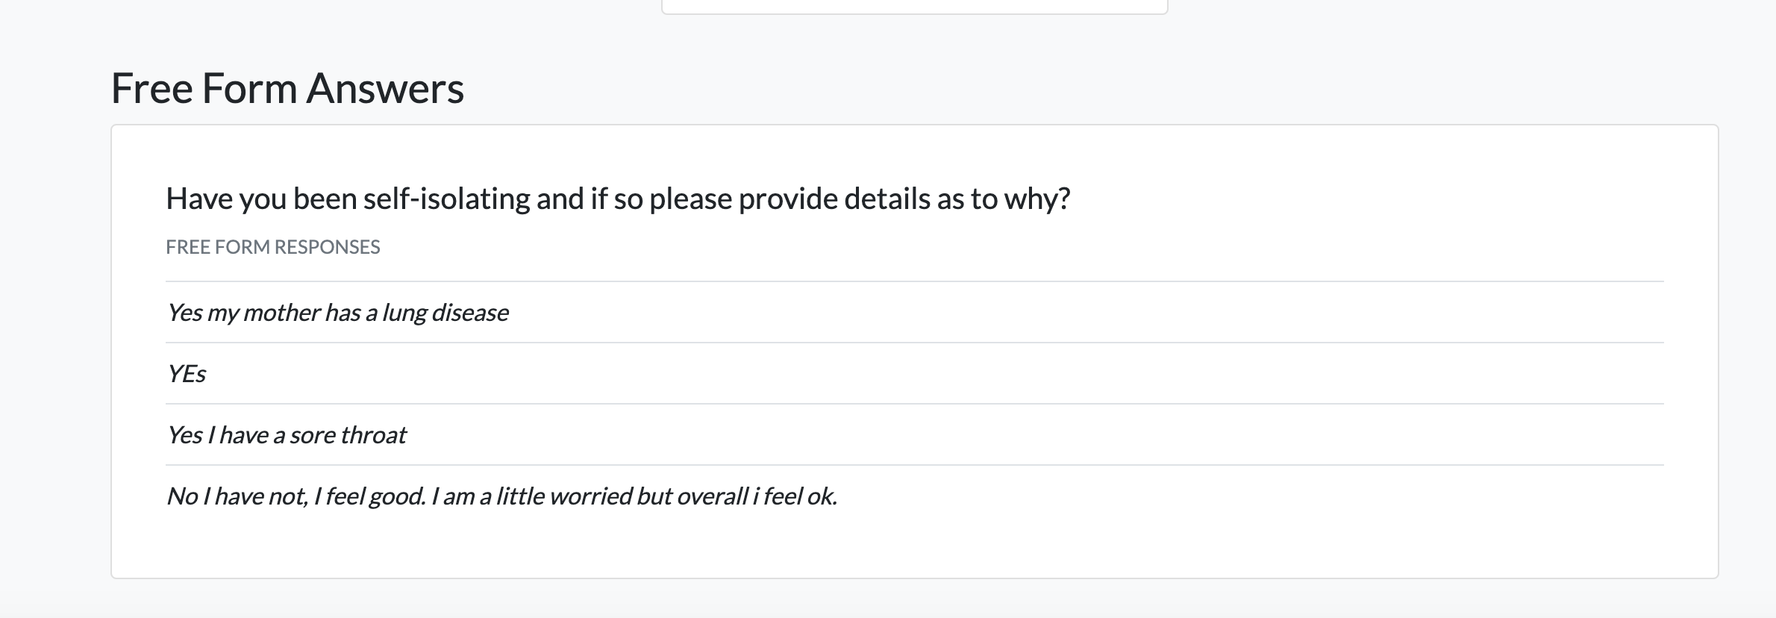

Figure 4.14 Responses to a free form question

Figure 4.13 shows the users are being asked questions about the coronavirus outbreak. Users have chosen options some said all of the answers and some decided to choose none. Using a free form questions like the one in Figure 4.14 can help the campaign owner get a sense of the answers by extracting keywords and categorising the text to see what people were talking about. Categorisation explores the Watson NLU five-level taxonomy themes[7] of the words in a user response. The categories can reveal dimensions of words used by the responders and find frequently occurring themes. The longer the given answer the better the categorisation of the theme in the response.

The benefits of chatbots and freeform responses becomes clearer in the following figures. Figure 4.15 shows the results of the analysis being run on user responses to free form questions. These are questions that are posed to the public when they choose a multiple-choice question.

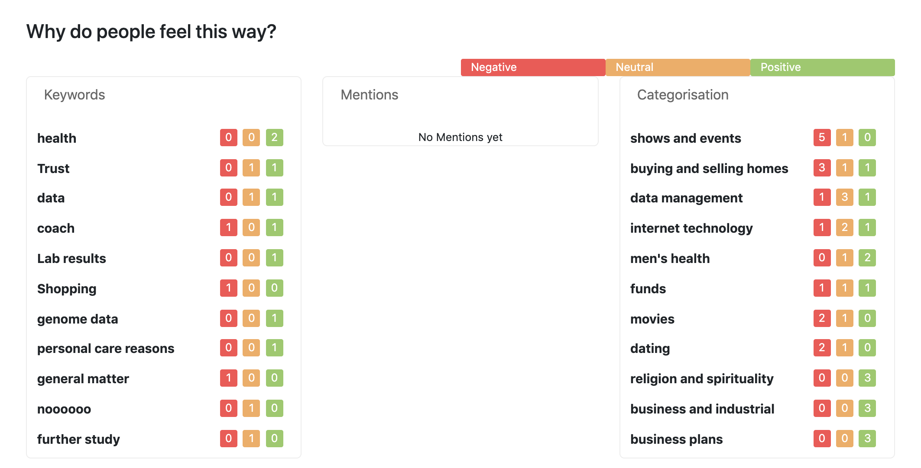

Figure 4.15 Social Campaign Manager dashboard viewing analysis of answers to why questions

Figure 4.16 shows a word cloud of all free form responses including open questions from above and all free form text that was not recognised as a predefined answer to a question from the form above.

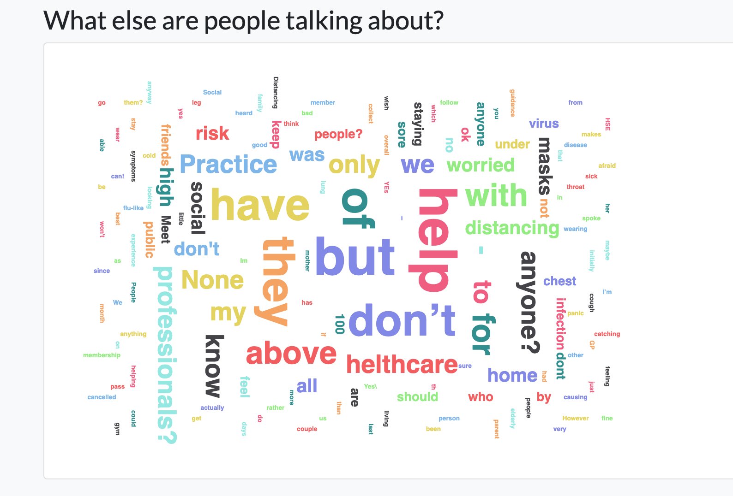

Figure 4.16 Viewing the word cloud of all free form answers including answers not fitting the question

Finally, the dashboard can extract responses from the public that the bot has been unable to answer or understand. Figure 4.16 shows a question which some users answers differently to what was asked. Many people replied saying that masks “*don’t help healthy people*“ which was not an available answer in the multiple choice answers list. This section will show policy makers where users are struggling to understand the questions or have different opinions to the subject. Using the edit button on the campaign, policy makers can change the text to make it clearer or add an example to make sure people understand what is being asked of them.

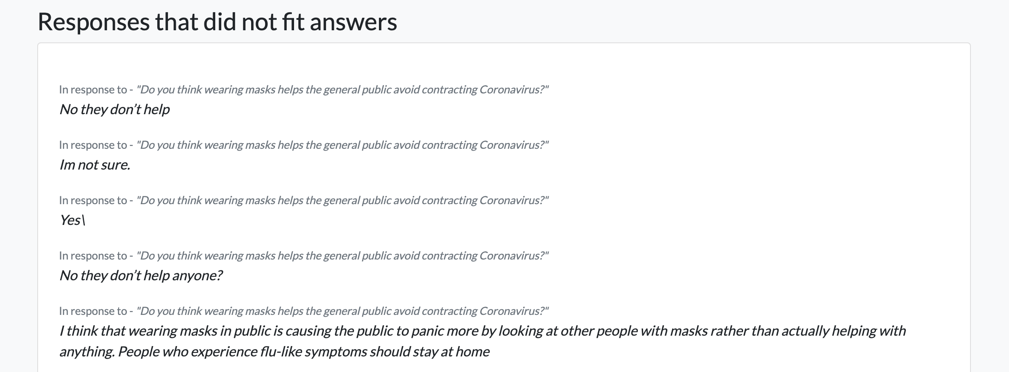

Figure 4.17 Viewing user questions chatbot was unable to answer

### Refining the campaign questions and answers

It is worth mentioning that when a policy maker creates a campaign using the logic above, it is only the first step in making sure everything runs smoothly. Chatbots at the end of the day are solutions that compare words in a computer way rather than in a human way. What is meant by this is, the campaign creation is just the first step in the refining process. What the Social Campaign Manager is built for is updating the campaign on the fly whenever the user sees fit. The campaign creators are encouraged to spend some time with real questionnaire participants to iron out potential misunderstandings that the campaign might cause and analyse participant responses as they come. Conversations change depending on context and other external factors. Misunderstandings are inevitable, therefore each campaign owner is recommended to go through a process of refining after initial conception.

### Editing a campaign

Any running campaign can be edited while it is running. The owner can update the questions or add extra multiple-choice answer items to questions. The campaign owner is able to go through the form in a similar fashion as if they were creating the campaign. They just need to publish the campaign and it will be instantly available through all channels. The campaign name cannot be edited once the campaign is running.

### Deleting a campaign

If a campaign is finished and/or it is no longer needed, it can be deleted by pressing the *Delete Campaign* button at the bottom of the edit campaign view below in the background in Figure 4.17. This will open up a modal asking for user confirmation of the name of the campaign being removed. Deleting a social media campaign removes all records related to the questionnaire and all data collected throughout the duration of the campaign.

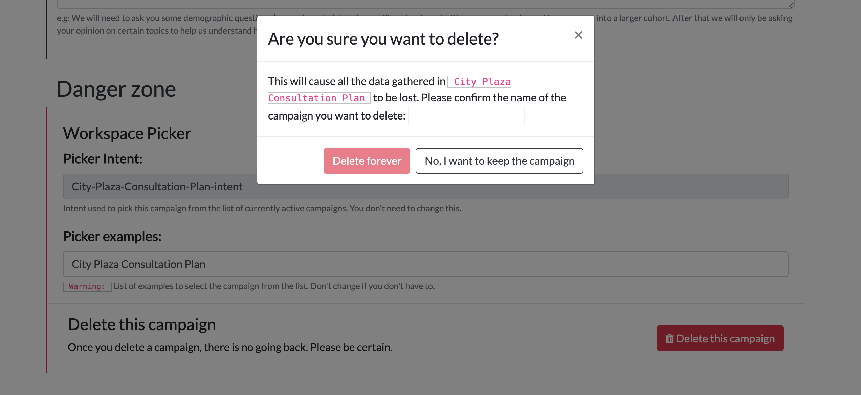

Figure 4.18 Social Campaign Manager - Deleting a campaign and all its data

# Conclusion

The Social Campaign Manager has realised the potential of using open social data sources for the purpose of ‘catching the voice of the public’ using the social media networks. It has not only provided a set of Application Programming Interfaces that provide access to open social data, but also created an innovative platform that enables policy makers to explore the vast potential of social media as a direct source of meaningful data. The SCM has been used to run the first successful public trial using the platform after a preliminary private trial. Both trials provided invaluable feedback in terms of running an effective social media campaign and in providing insight into what kind of information is relevant to policy makers in public consultations. More trials on the horizon will help to further develop the Social Campaign Manager beyond its current state.

1. <https://console.bluemix.net/catalog/services/watson-assistant-formerly-conversation>
2. <https://console.bluemix.net/catalog/services/natural-language-understanding>
3. Jakuben, B. (2019). Intents, Entities, and Dialogs. [online] Treehouse. Available at: <https://teamtreehouse.com/library/intents-entities-and-dialogs> [Accessed 26 Nov. 2019].
4. Codecademy. (2019). What is REST? | Codecademy. [online] Available at:

   <https://www.codecademy.com/articles/what-is-rest> [Accessed 25 Nov. 2019].
5. Cloud.ibm.com. (2019). Cloudant - IBM Cloud. [online] Available at: <https://cloud.ibm.com/catalog/services/cloudant> [Accessed 16 Dec. 2019].
6. In Cloudant a ‘*Database*’ is the equivalent to a typical NoSQL collection or a table in relational databases.
7. <https://cloud.ibm.com/docs/services/natural-language-understanding?topic=natural-language-understanding-categories-hierarchy>